

RECORD NOTEBOOK

OBJECT ORIENTED SOFTWARE ENGINEERING - (EBCS22L07)

2024-2025 (EVEN SEMESTER)
DEPARTMENT OF
COMPUTER SCIENCE AND ENGINEERING

NAME : KUMARAN T
REGISTER NO : 231061201005
COURSE : B. TECH CSE
YEAR/SEM : II / IV



BONAFIDE CERTIFICATE

Register No. : 231061201005
Name of Lab : OBJECT ORIENTED SOFTWARE ENGINEERING – (EBCS22L07)
Department : COMPUTER SCIENCE AND ENGINEERING

Certified that this is Bonafide record of work done by KUMARAN T of II Year B-Tech CSE in the OBJECT ORIENTED SOFTWARE ENGINEERING during the year 2024-2025.

Signature of Lab-in-Charge Signature of Head of Dept

Submitted for the Practical Examination held on _____________________

Internal Examiner External Examiner

TABLE OF CONTENT

EXP.NO | DATE | EXPERIMENTS | PAGE NO | STAFF SIGNATURE
01 | 02/06/2025 | Study of star UML | 01
02 | 02/06/2025 | Online railway reservation system | 05
03 | 02/06/2025 | Student mark analysis system | 13
04 | 03/06/2025 | Payroll processing application | 21
05 | 03/06/2025 | Inventory system | 28
06 | 03/06/2025 | Automating the banking process | 36
07 | 04/06/2025 | Course registration system | 45
08 | 04/06/2025 | Library management system | 53
09 | 04/06/2025 | Passport automation system | 60

STUDY OF STAR UML
AIM:
To study the basics of STAR UML

INTRODUCTION:

Star UML is an open-source software modeling tool that supports the UML (Unified Modeling Language) framework for system and software modeling. It is based on UML version 1.4, provides eleven different types of diagrams, and accepts UML 2.0 notation, It actively supports the MDA (Model Driven Architecture) approach by supporting the UML profile concept and allowing togenerate code for multiple languages.
SYSTEM REQUIREMENTS:

Windows 2000, Windows XP, or higher; Microsoft Internet Explorer 5.0 or higher; 128 MB RAM(256MB recommended); 110MB hard disc space (150MB space recommended)

INSTALLATION

The installer follows the classic Windows install procedure without issues.

STEPS FOR DOWNLOADING STAR UML
STEP 1: Search Star UML in google

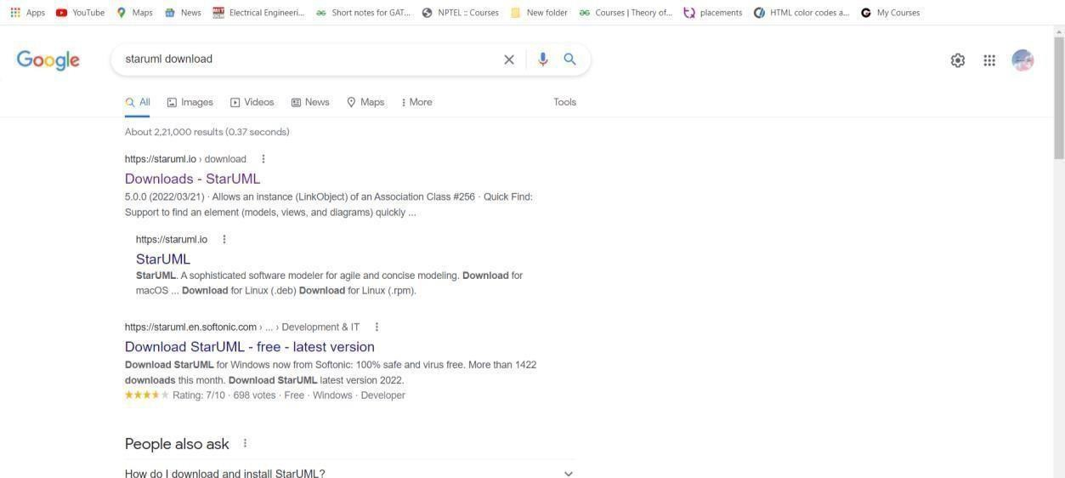

STEP 2 : Download for Mac OS/Windows/.deb, .rpm
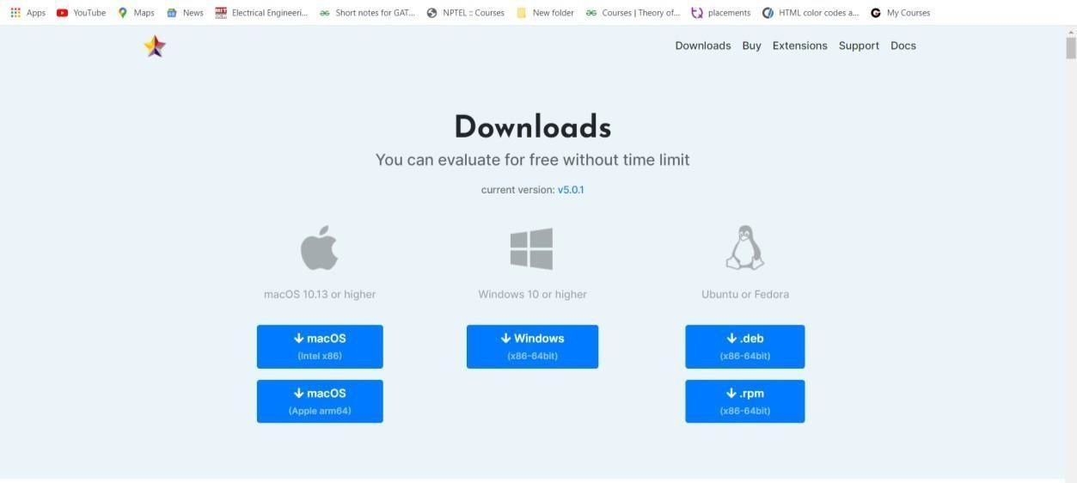

STEP 3 : Install it
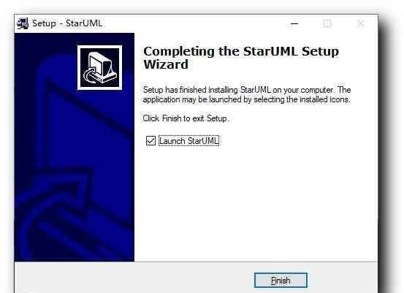
DOCUMENTATION

The same help that could be browsed on the StarUML website is available with the tool on your desktop Documentation describes the concepts of the tool but on high-level vision.
More detailed documentation is available for the diagramming functions. Sample projects are provided with the tooland one of them contains the model of the tool itself, showing that the developers were able to eat their dog food. Besides English, documentation exists in Korean, Japanese, and Russian.

Some general and diagram configuration options are available from the Tools/Options menu. You willfind in this window also the configuration switches for the code generation. The interface is also very configurable as you can select what part of the tool you would like to view or not.
FEATURES
When you start a new project, StarUML proposes which approach you want to use:4+1 (Kruchten).Rational, UML, components (from Cheesman and Daniels book), default or empty. Depending on theapproach, profiles and/or frameworks may be included and loaded. If you don't follow a specific approach, the "empty" choice could be used. Although a project can be managed as one file, it maybeconvenient to divide it into many units and manage them separately if many developers are working on it together.

StarUML. makes a clear conceptual distinction between models, views, and diagrams. A Model isanelement that contains information for a software model. A View is a visual expression of the information contained in a model, and a Diagram is a collection of view elements that represent theuser's specific design thoughts.

StarUML is built as a modular and open tool. It provides frameworks for extending the functionality of the tool. It is designed to allow access to all functions of the model/meta- model and tool through COM Automation, and it provides an extension of menu and option items. Also,users can create theirown approaches and frameworks according to their methodologies. The toolcan also be integrated with any external tools.
StarUML supports the following Diagram types

- Use Case Diagram
- Class Diagram
- Sequence Diagram Collaboration Diagram
- State chart Diagram
- Activity Diagram
- Component Diagram
- Deployment Diagram
- Composite Structure Diagram

RESULT:

Thus the basics of star UML have been studied successfully.

ONLINE RAILWAY RESERVATION SYSTEM

AIM:
To develop the online railway reservation system using star uml.

PROBLEM ANALYSIS AND PROJECT PLANNING

INTRODUCTION
This document deals with online ticket reservations for the railway. This document is designed in such a way that the reader understands it. The use case description and other documents are describedin such a way that the system reaches the people easily.

OBJECTIVES
The purpose of the document is to know about the availability of seats, railway, etc. According to therequirements, the passenger reserves his/her tickets.

SCOPE
This document for online ticket reservations for airlines makes the work easy for the passenger tobook tickets.

PROBLEM STATEMENT
Computers are an integral part of our day-to-day life. It makes the work easy and faster. Every job is computerized now. So is the ticket reservation, we can book our tickets online. During the reservationof tickets, the passenger has to select the origin and date of the journey. passport number, etc.,
The reservation counter keeps track of the passenger's information. The system will have all thedetails about the trains and the facilities provided by them. There are various trains provided according to the convenience of the passenger. A database is maintained by the database administrator.

USE CASE DIAGARM
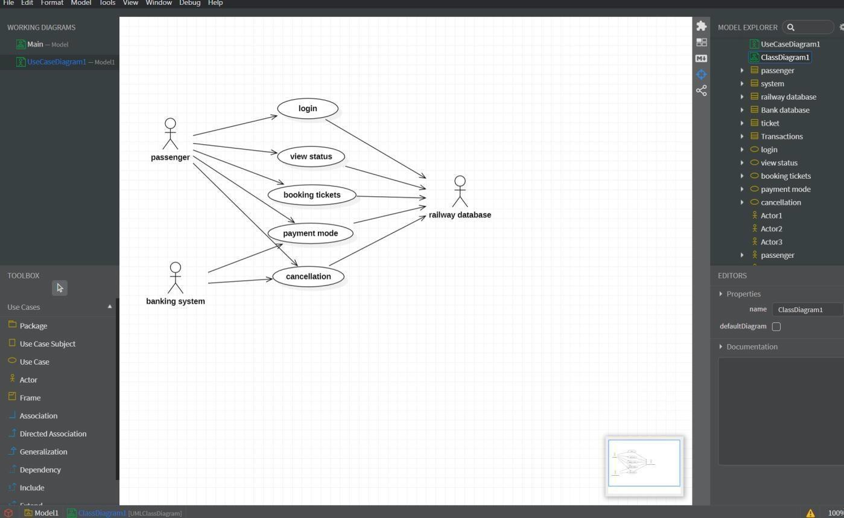

ACTIVITY DIAGRAM
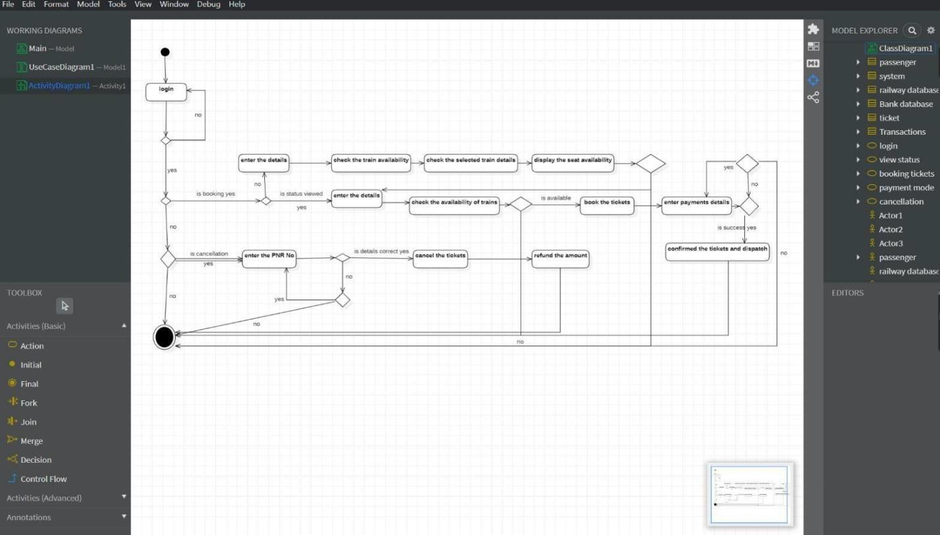

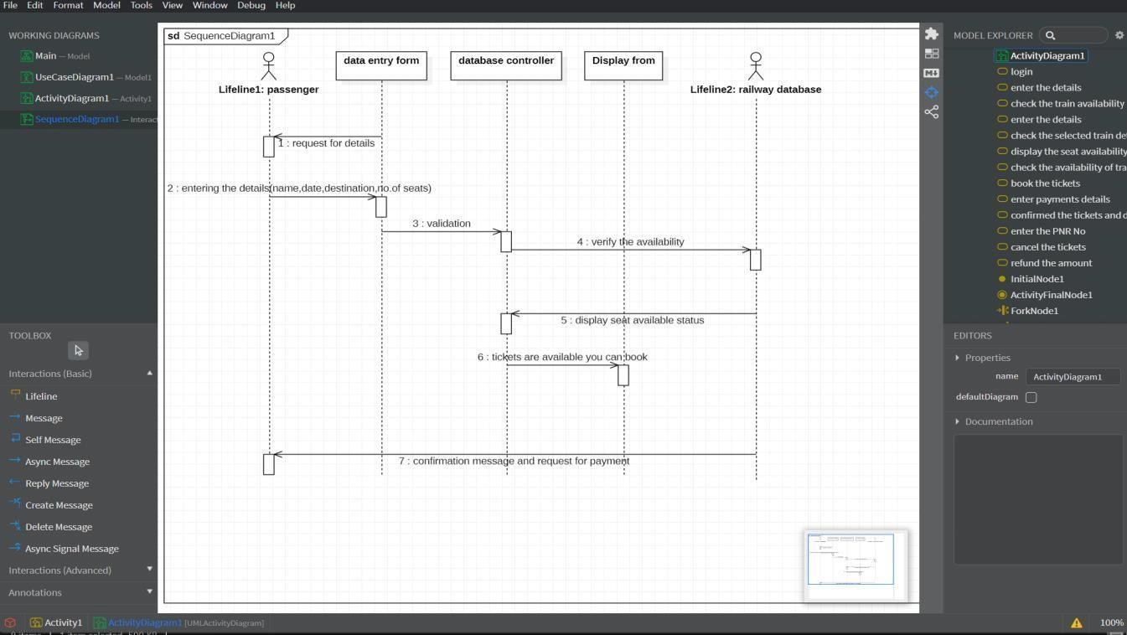

COMMUNICATION DIAGRAM
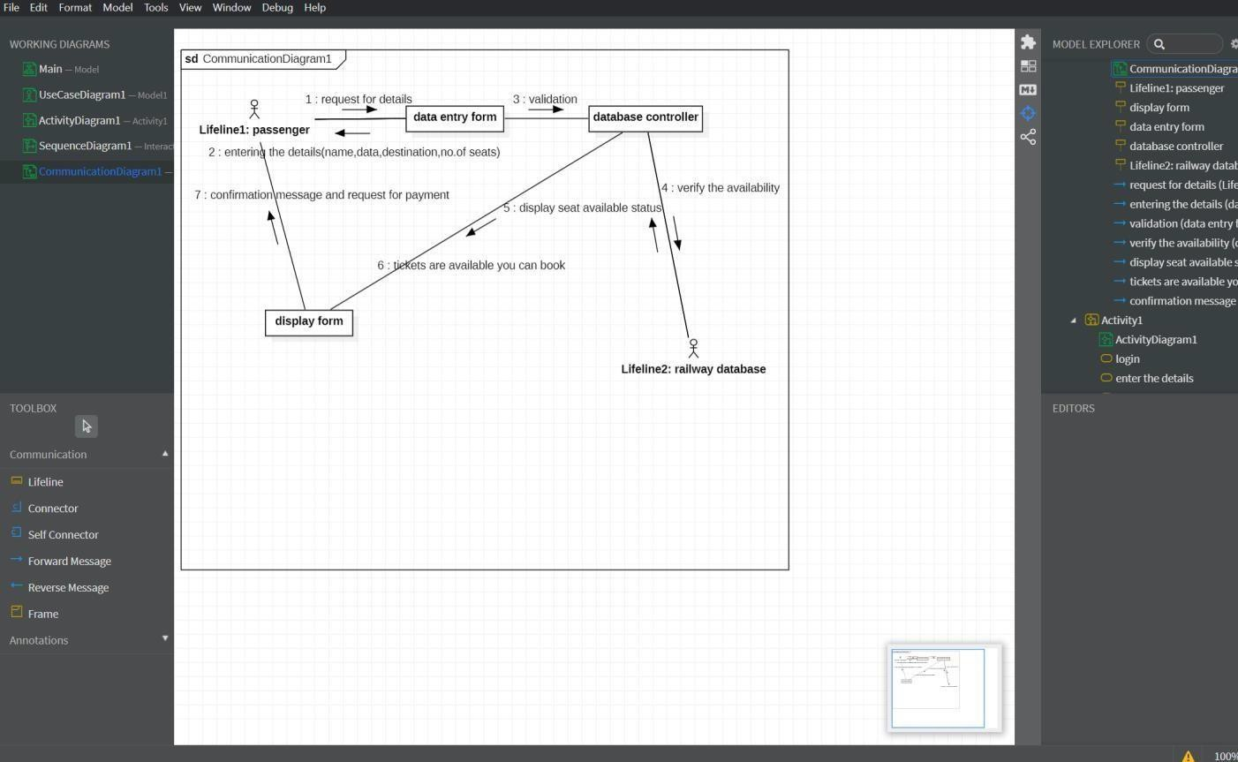

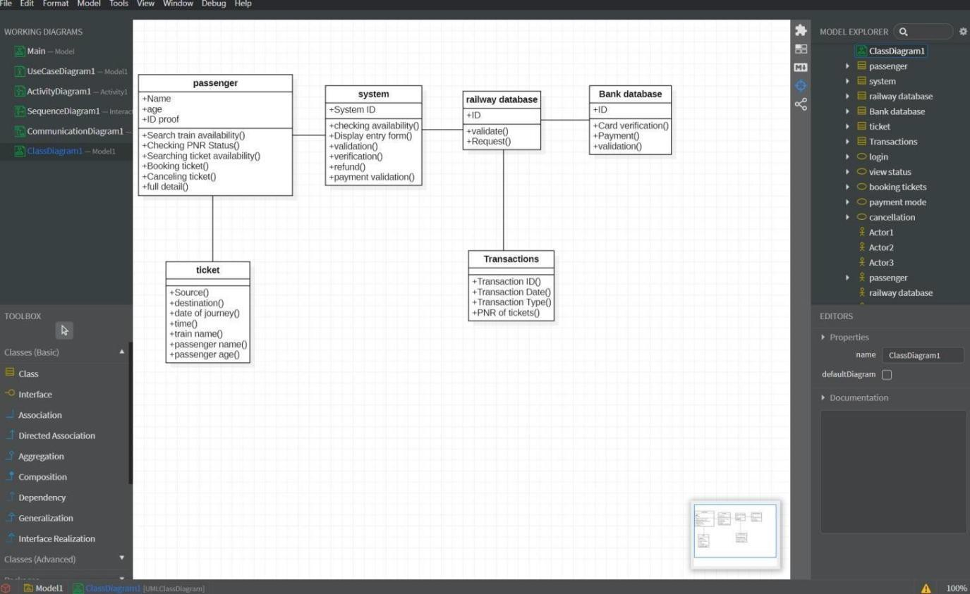

STEPS TO GENERATE CODE IN STAR UML

- Draw the class diagram and then save it.

- Open the saved file with star uml.

- Then go to tools at right corner.

- Select the code language which we can prefer.

- Then we have the code generator in tools so give access to it.

- Then go to tools and select the language then it will take us to another window.

- There select the class attribute to generate the code.

- Then it will ask for the directory to store the code.

- Select the directory and click on generate code.

- Then code generated successfully.

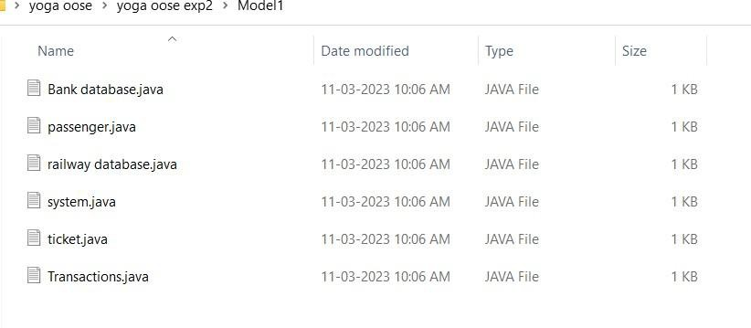

BANK DATA BASE
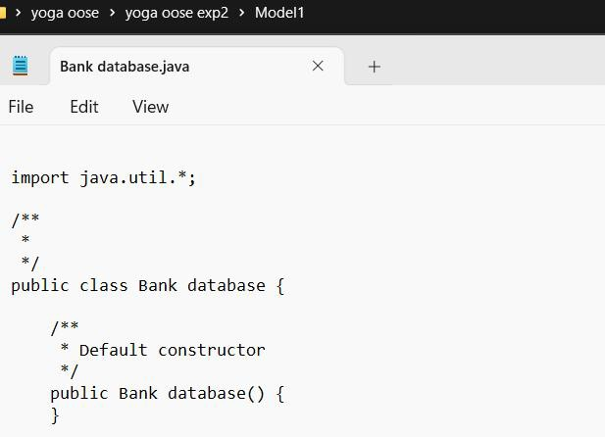

PASSENGER
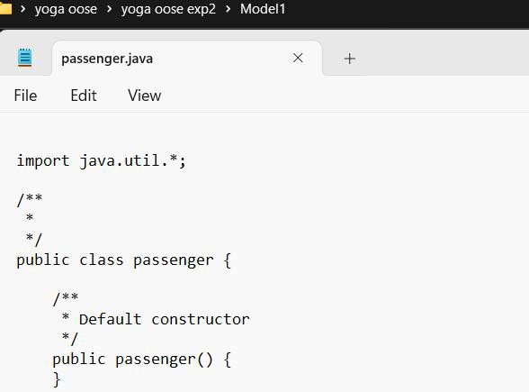

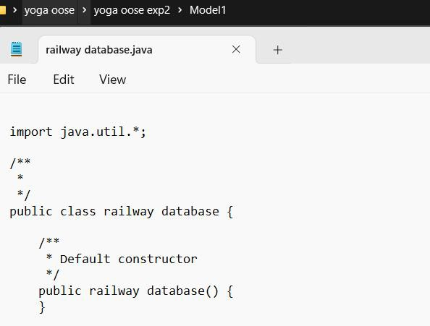

SYSTEM

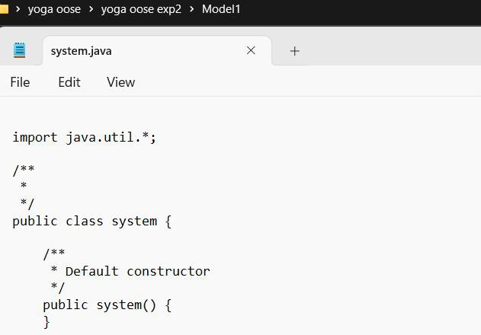

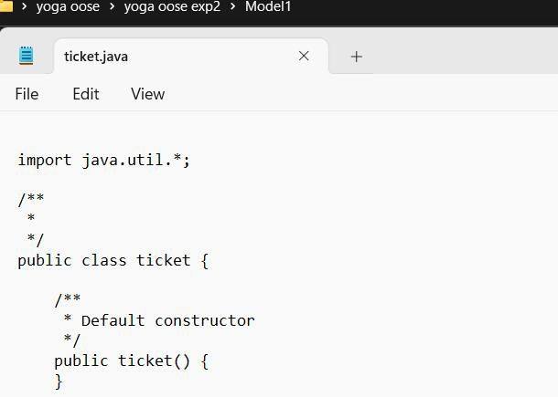

TRANSACTIONS
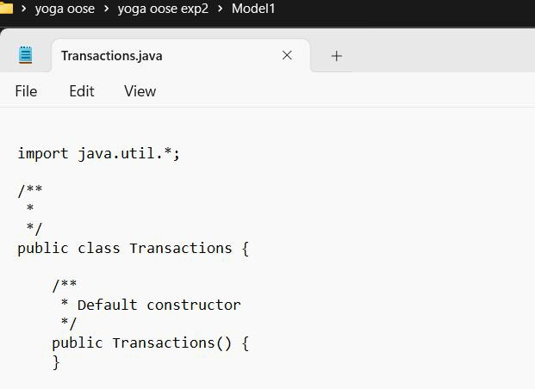

Result:

Thus, the UML diagrams for the online railway reservation system in StarUML have been designed and a java code template was generated successfully.

Ex. No:3 Date:02/06/2025

STUDENT MARK ANALYSIS SYSTEM

AIM:
To develop the Student Mark Analysis System using StarUML.

PROBLEM ANALYSIS AND PROJECT PLANNING INTRODUCTION
Student mark analyzing system has been designed to carry out the mark analysis process in an educational institution. The results of respective departments can be efficiently computed withoutmuch manual involvement.
OBJECTIVES
The purpose of this project is to define the requirements of the mark analysis system. This system reduces manual work to a great extent. The mark analysis is carried out by the system in an efficient manner.
SCOPE
This system is very essential for every educational institution as it reduces manpower. This systemcan be used by all kinds of educational institutions to evaluate and analyze the marks and generatereports of specified criteria.
PROBLEM STATEMENT
For analyzing the marks obtained by students in an educational institution. We are tasked to build up a student mark analyzing system. This is done to replace the manual entering and processing of marks which are error-prone and tedious. This system also maintains information about students. The system will have a Windows-based desktop interface to allow the faculty to enter marks obtained by the students, update them and generate various reports.
For security reasons, the administrator and faculty only can update the marks and other information. First, the user needs to login into to the system for accessing it. The system will retain information on all the students and the institution.
The system analyses the marks and generates the result reports. The marks and information about the students are stored in a database and the system works with the database. The faculty can enter the marks and student information through a visual environment. The updated details are stored in the database. The system generates the overall result by analyzing the marks. Mark analyzer monitors this process. One of the most important features of the system is creating reports based on the given criteria. The user can create the following reports.

USE CASE DIAGRAM
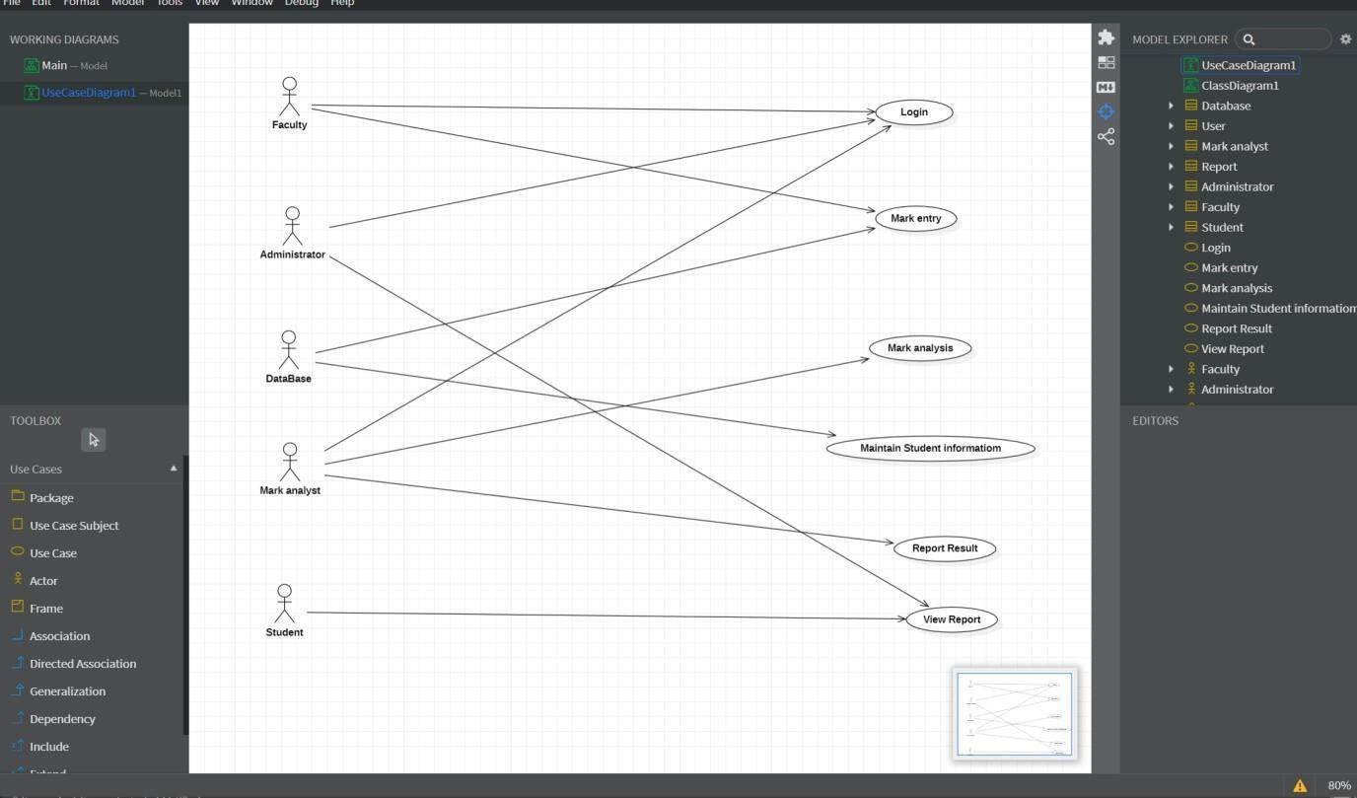
ACTIVITY DIAGRAM
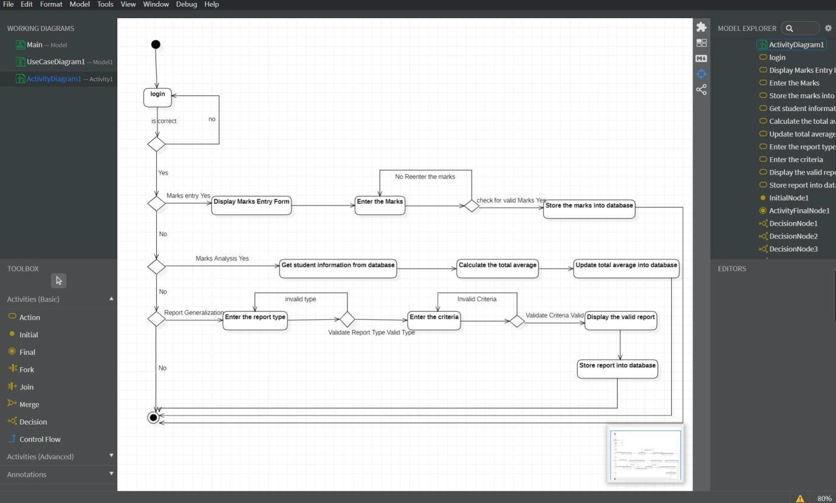

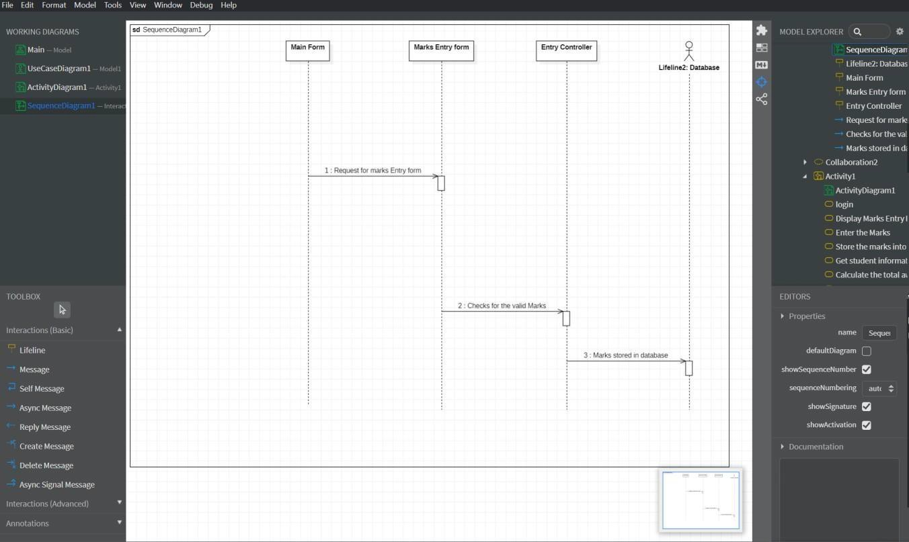

COMMUNICATION DIAGRAM

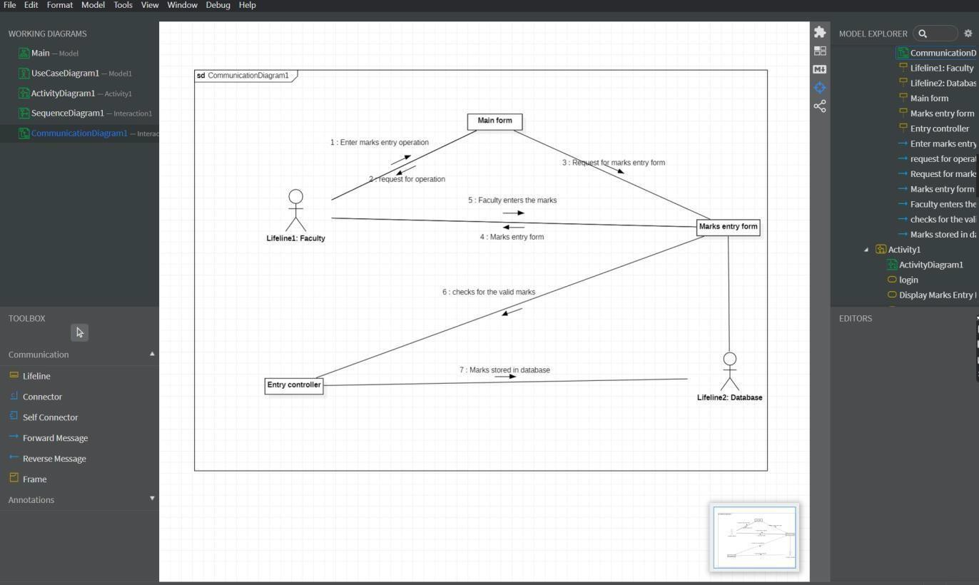

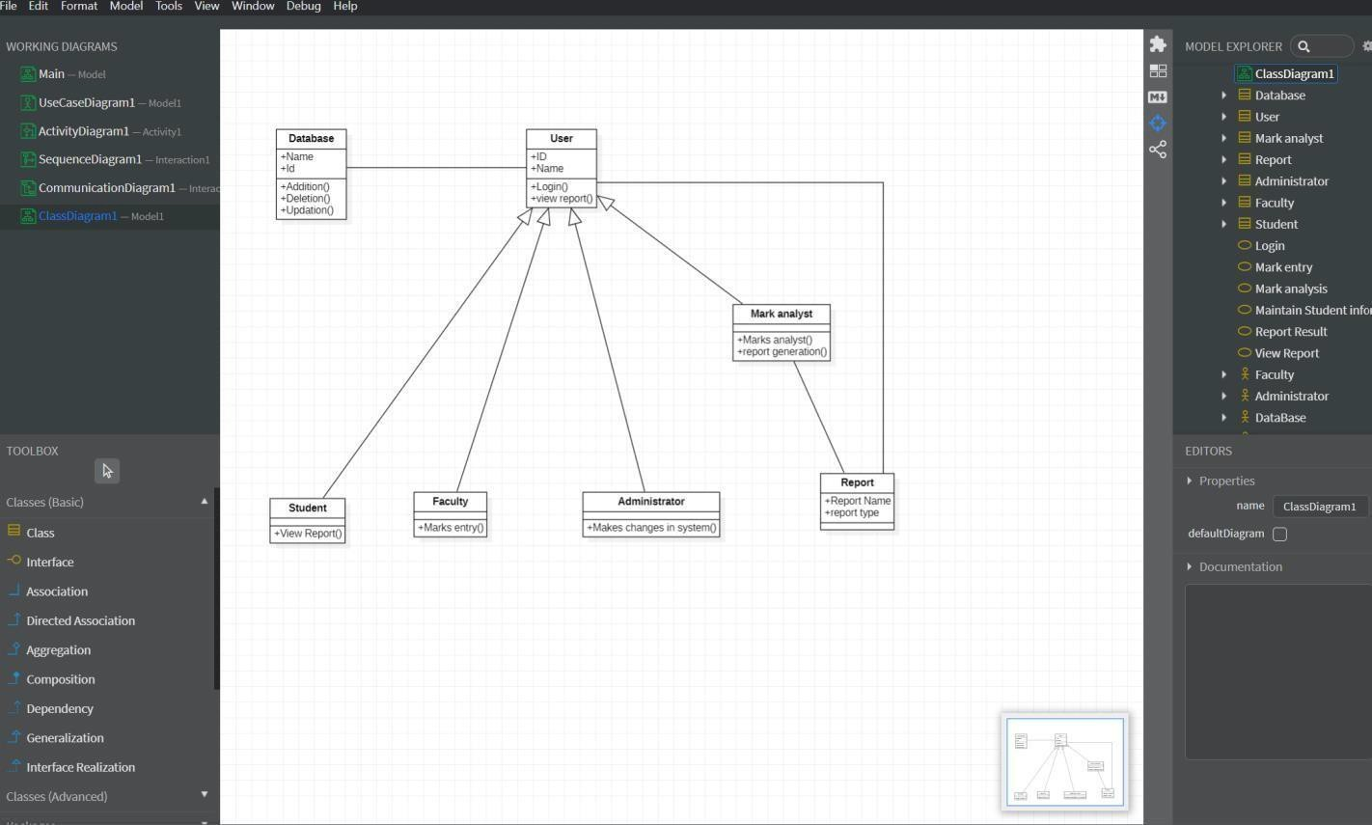

STEPS TO GENERATE CODE IN STAR UML

  - Draw the class diagram and then save it.

  - Open the saved file with star uml.

  - Then go to tools at right corner.

  - Select the code language which we can prefer.

  - Then we have the code generator in tools so give access to it.

  - Then go to tools and select the language then it will take us to another window.

  - There select the class attribute to generate the code.

  - Then it will ask for the directory to store the code.

  - Select the directory and click on generate code.

  - Then code generated successfully.

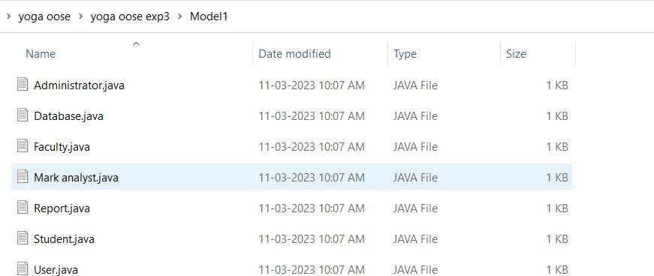

ADMINISTRATOR
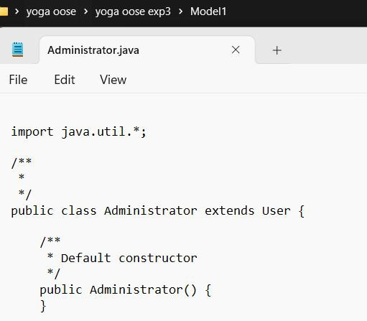

DATA BASE
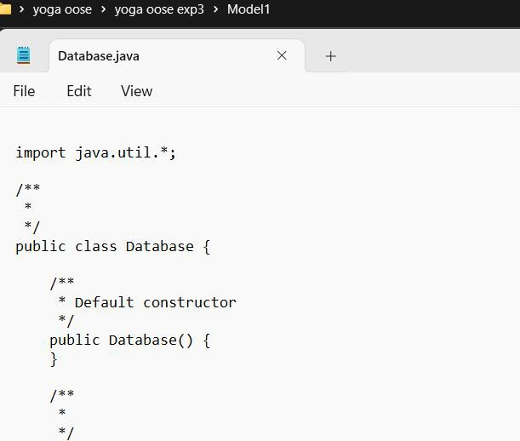

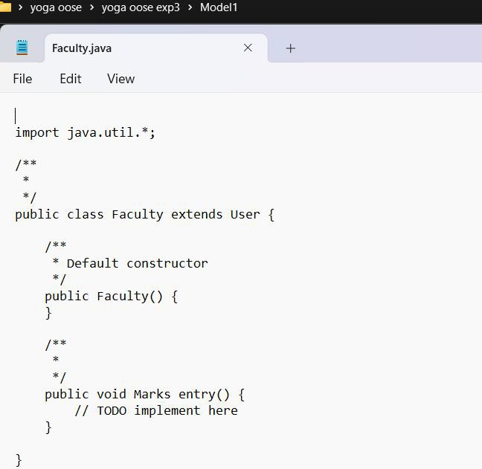

MARK ANALYST
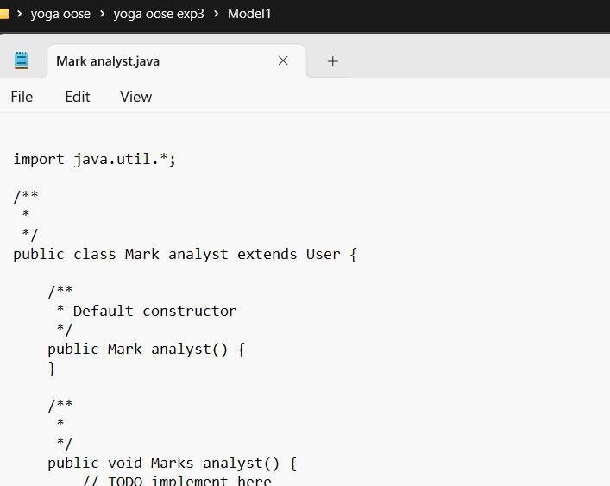

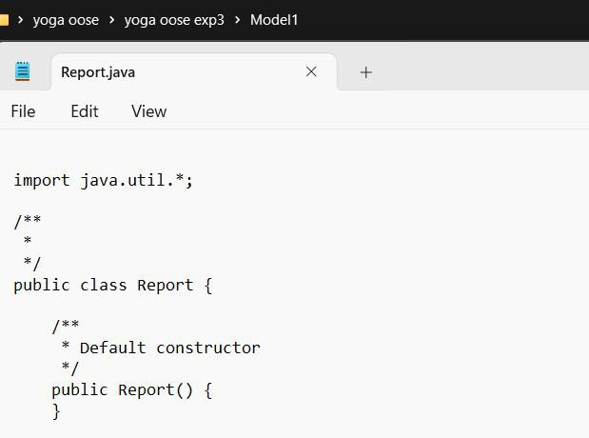

STUDENT

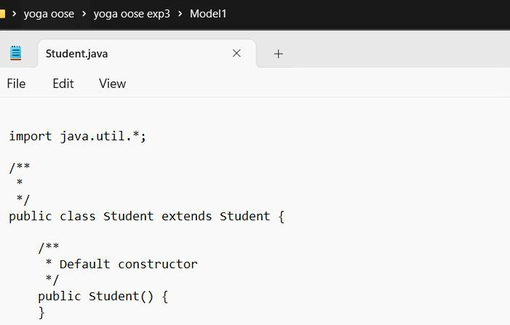

USER
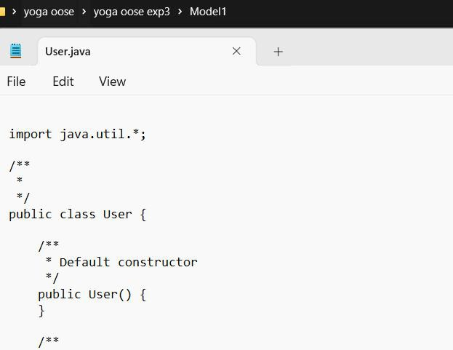

Result:
Thus, the UML diagrams for Student Mark Analysis system in StarUML have been designedand java code template was generated successfully.

AIM:

PAYROLL SYSTEM

To develop the Payroll System using StarUML.

INTRODUCTION
This document deals with online Payroll Processing System. This document is
designed in such a way that the reader understands it. The use case description and otherdocuments are described in such a way that the system reaches the people easily.

OBJECTIVES
To develop a user-friendly online pay roll processing system which makes the workeasy and faster.

SCOPE
This project describes about the payroll system, there are two types of Users, normal
users and Administrator. Users can log on the directory by a unique User ID that is providedto them and for every ID check there is a password. Administrator does authorization, he is the manager of that directory, and he can Search employee details with names and their employee id. This would help users to Create or find employee details easily.

PROBLEM STATEMENT
Designing a payroll system for users and administrator through Authentication Process, where only administrator can alter the data in Oracle database, Checking ID’s and passwordof authorized users.

USE CASE DIAGRAM
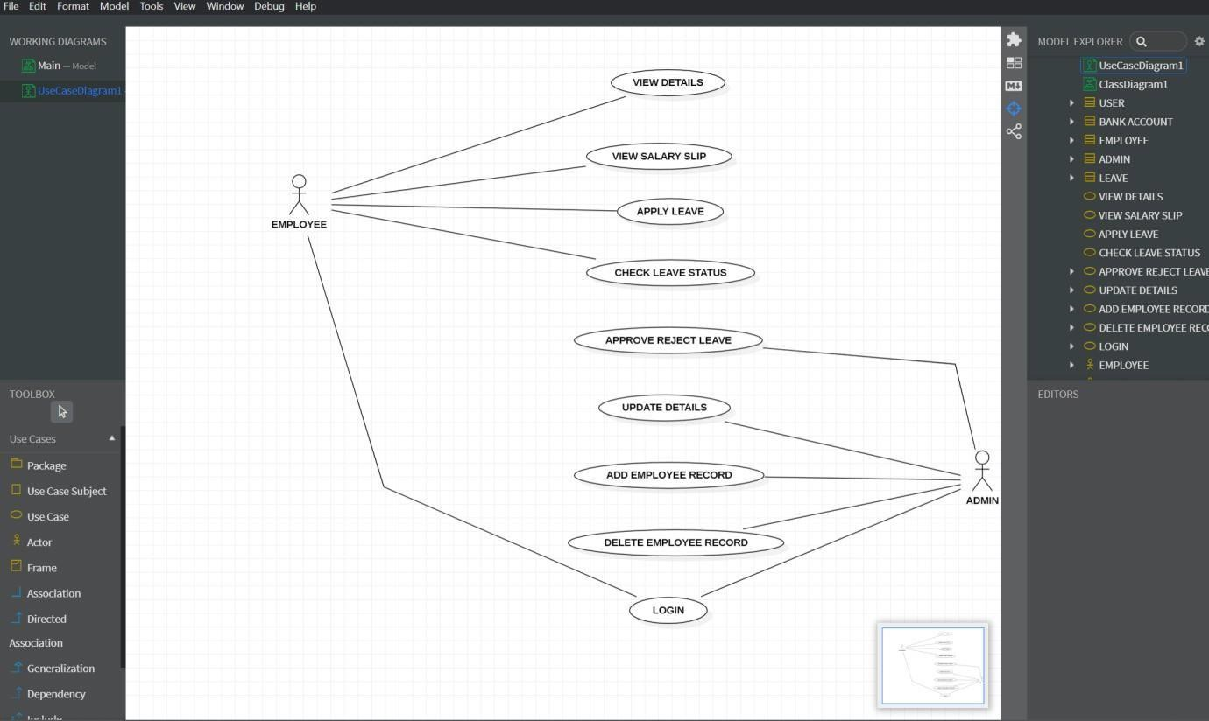

ACTIVITY DIAGRAM
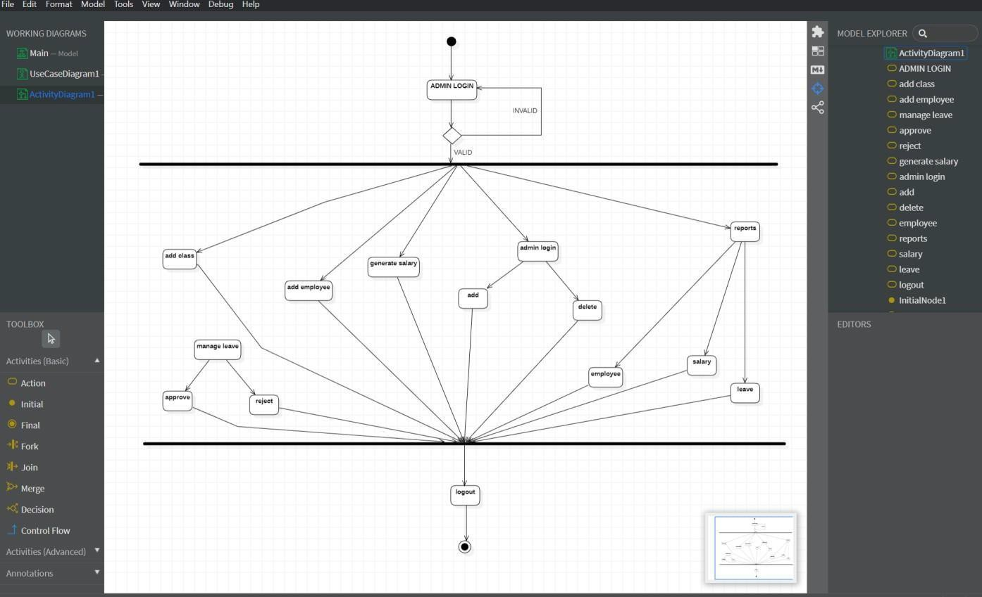

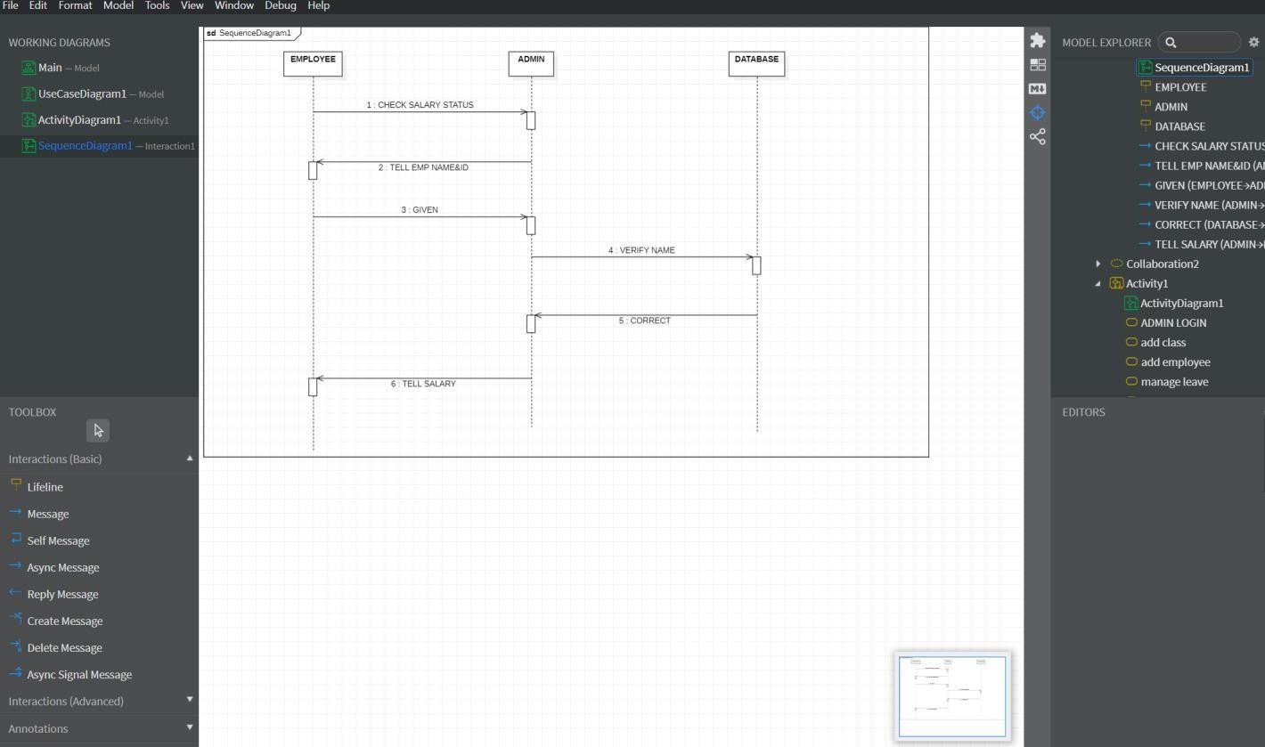

COMMUNICATION DIAGRAM
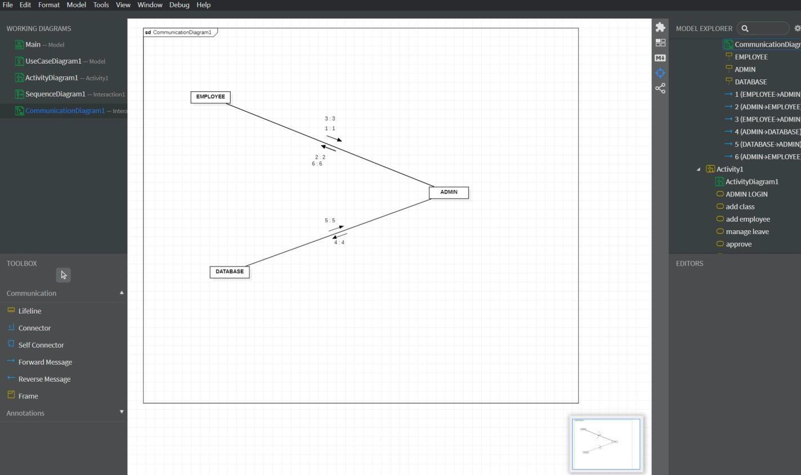

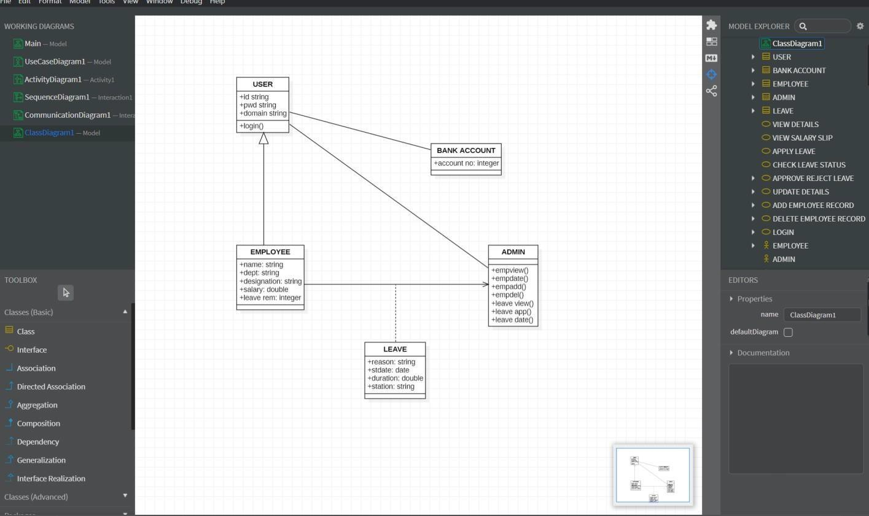

STEPS TO GENERATE CODE IN STAR UML
- Draw the class diagram and then save it.
- Open the saved file with star uml.
- Then go to tools at right corner.
- Select the code language which we can prefer.
- Then we have the code generator in tools so give access to it.
- Then go to tools and select the language then it will take us to another window.
- There select the class attribute to generate the code.
- Then it will ask for the directory to store the code.
- Select the directory and click on generate code.
- Then code generated successfully.

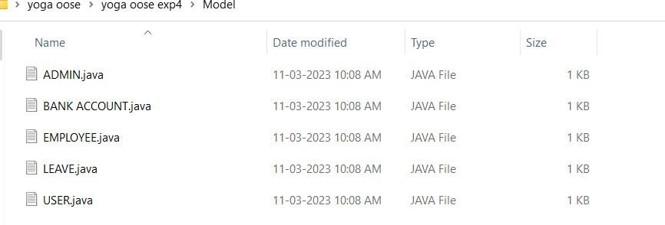

ADMIN
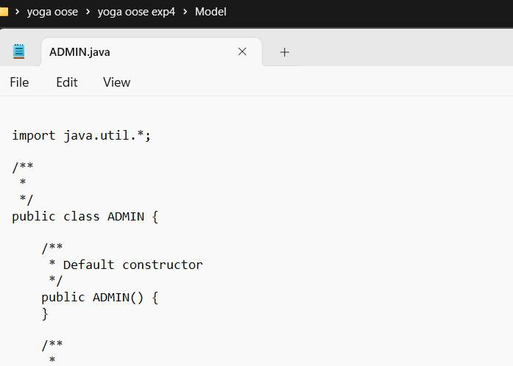

BANK ACCOUNT
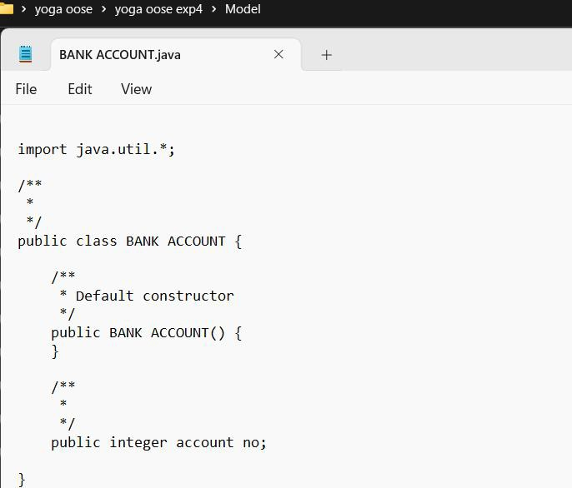

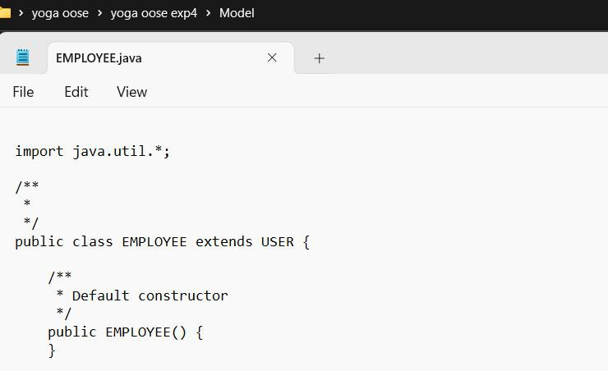

LEAVE
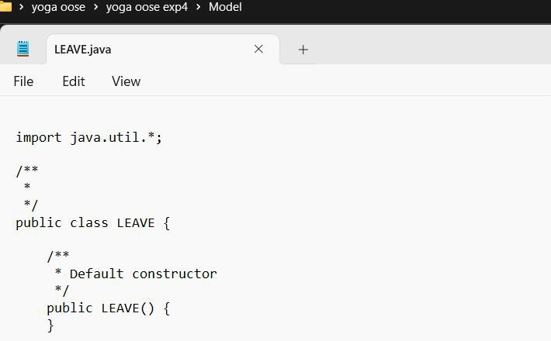

USER
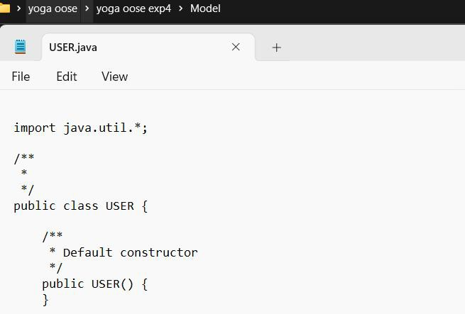

Result:
Thus, the UML diagrams for Payroll system in StarUML has been designed and java code the template was generated successfully.

AIM

INVENTORY SYSTEM

To develop the Inventory system using Star UML.

PROBLEM ANALYSIS AND PROJECT PLANNING INTRODUCTION
The stock maintenance system is basically for the customers who access the
information about the stock (here it is books in the book store) and retrieves the information.
OBJECTIVES
The purpose of the document is to define the requirements of the stock maintenance system. This supplementary specification lists the requirements that are not readily captured
in the use cases of the use case model. The supplementary specification & the use case modeltogether capture a complete set of requirement on the system.
SCOPE
This supplementary specification applies to the stock maintenance system. This specification defines the non-functional requirements of the system, such as reliability,
usability, performance and supportability as well as functional requirements that are commonacross a number of use cases.
PROBLEM STATEMENT
A new stock maintenance system for a book store is to replace the existing
maintenance system which is inefficient. The new stock maintenance system will allow theemployee to record information of the books available in the book store and generate reportbased on the total amount of sales.
The new system will have a Windows based desktop interface to allow employees to enter the information of sale, purchase orders, change employee preferences and create
reports. Employees can only access the information and purchase orders for security purpose.
The system retains information on all the books in the shop. The system retains the records of the cost, edition, author, publication of the books. The employee maintains the
information of the sale of books. He can add the books at right time and update the database.
The customer can view the availability of the required books and the price of thebooks. The customer can just view them but cannot make any changes.

USE CASE DIAGRAM
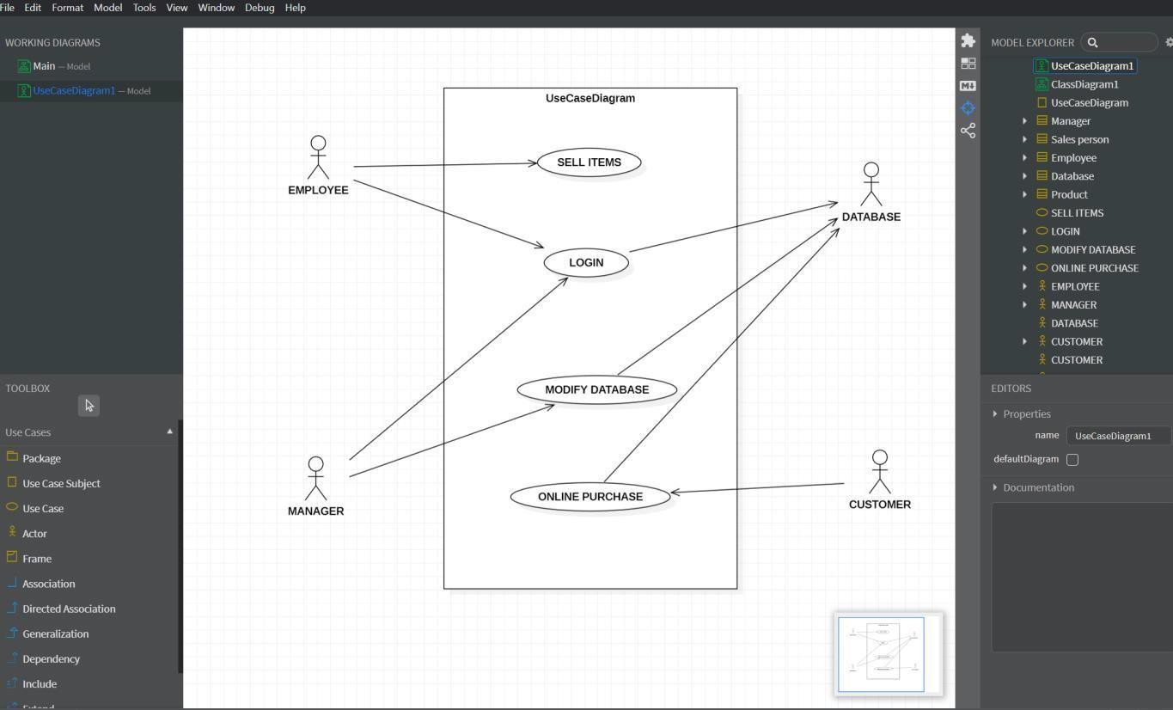

ACTIVITY DIAGARAM
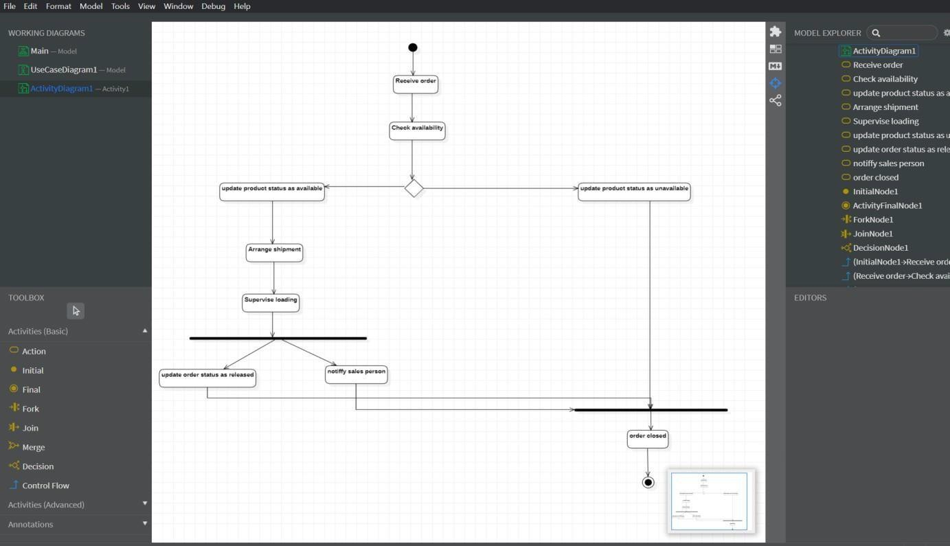

AVAILABILITY OF STOCKS
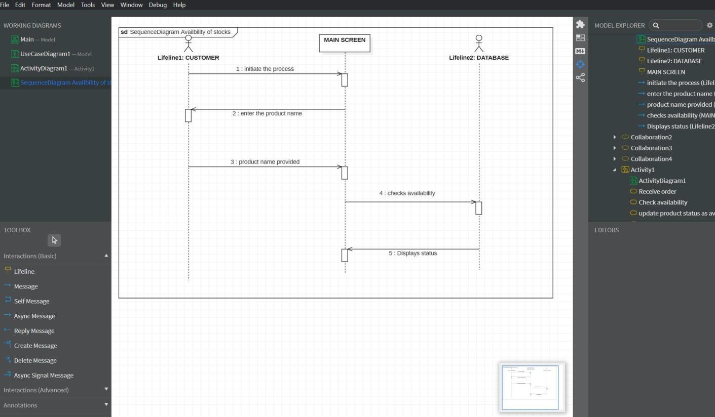

MANAGER POINT OF VIEW
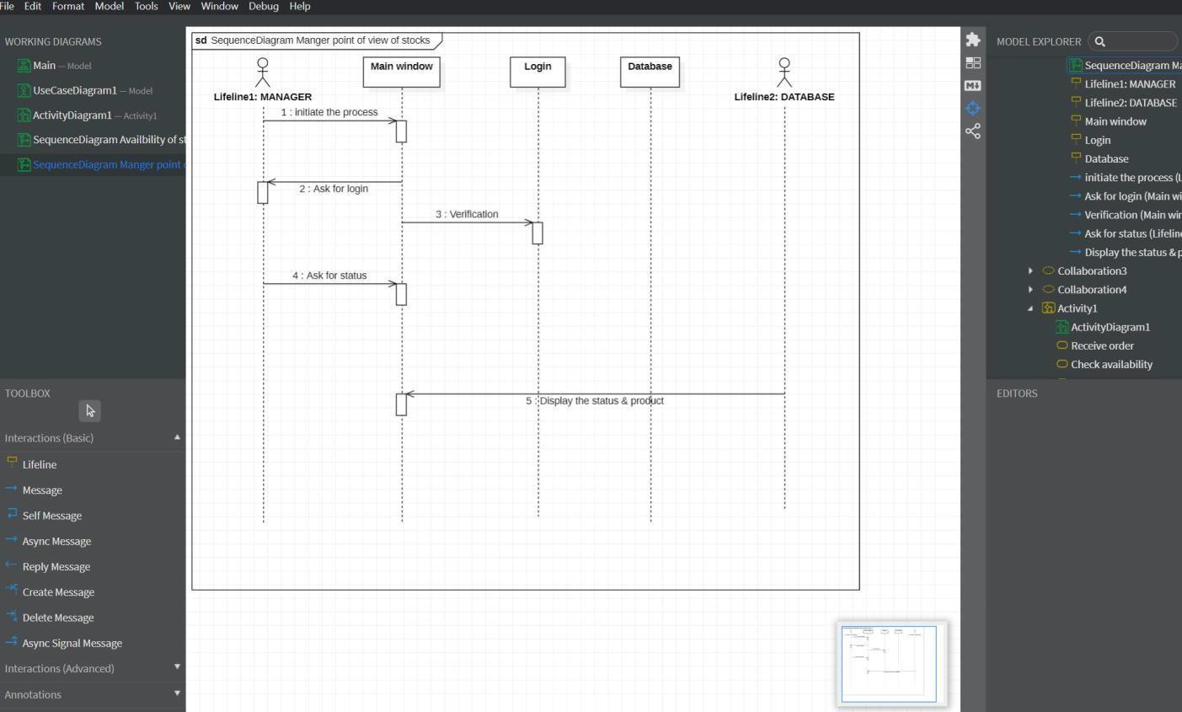

AVAILABILITY OF STOCKS
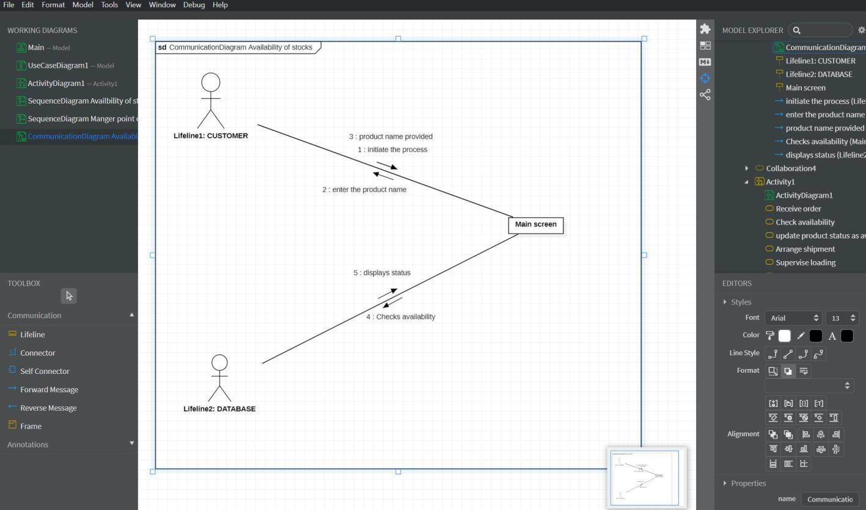

MANAGER POINT OF VIEW
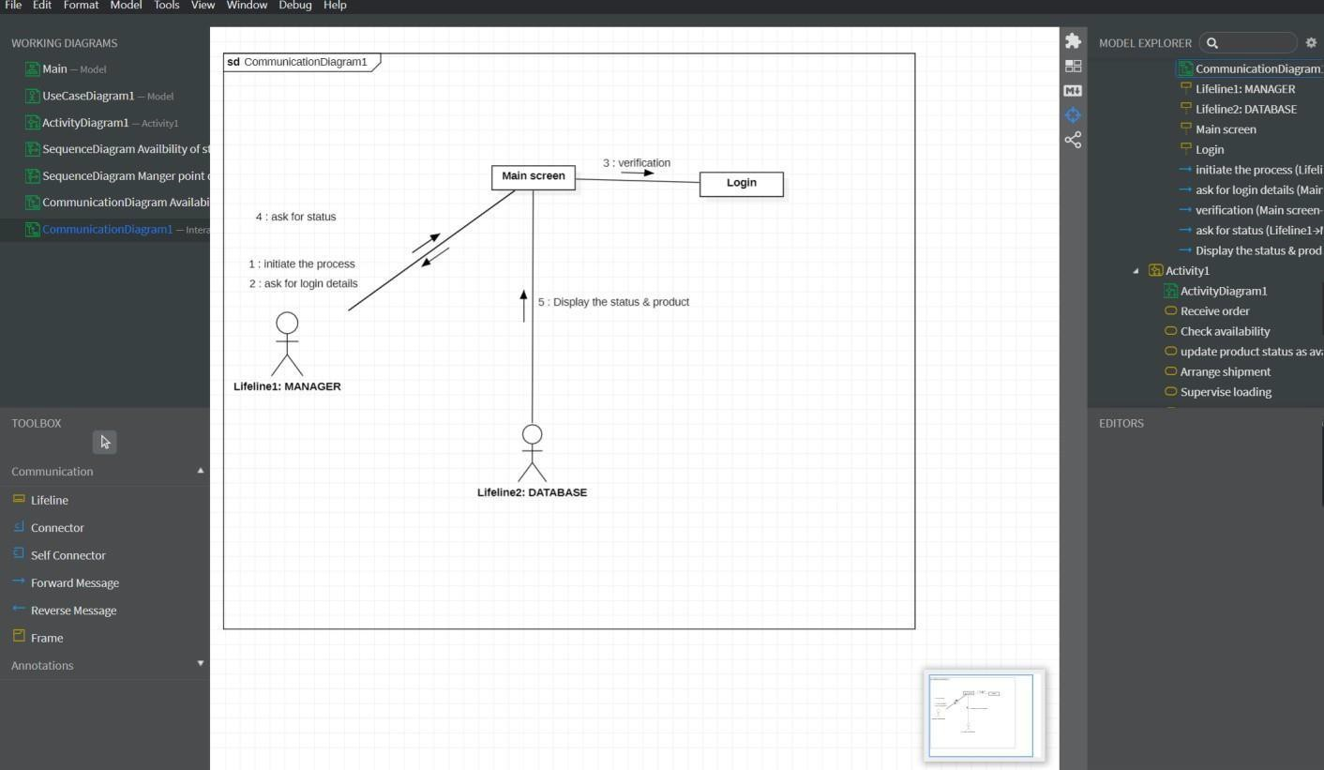

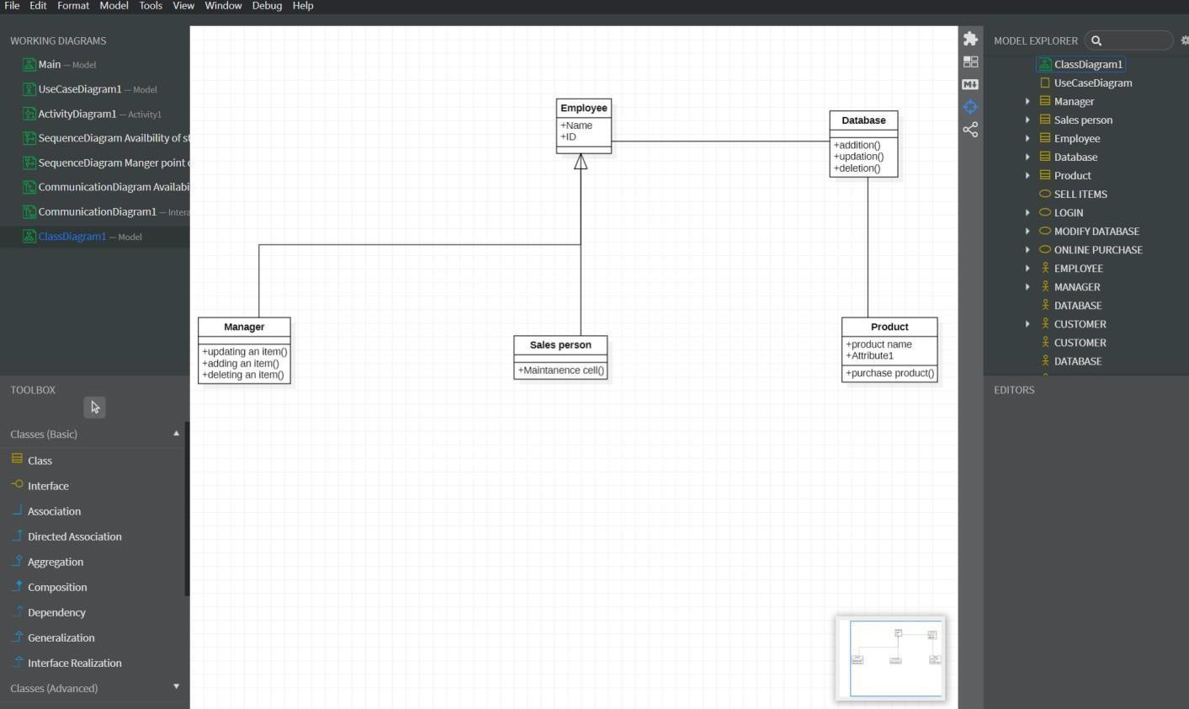

STEPS TO GENERATE CODE IN STAR UML

- Draw the class diagram and then save it.
- Open the saved file with star uml.
- Then go to tools at right corner.
- Select the code language which we can prefer.
- Then we have the code generator in tools so give access to it.
- Then go to tools and select the language then it will take us to another window.
- There select the class attribute to generate the code.
- Then it will ask for the directory to store the code.
- Select the directory and click on generate code.
- Then code generated successfully.

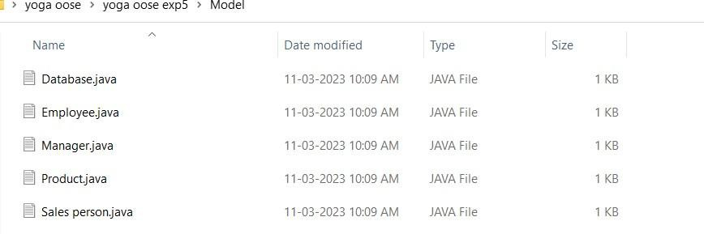

DATA BASE
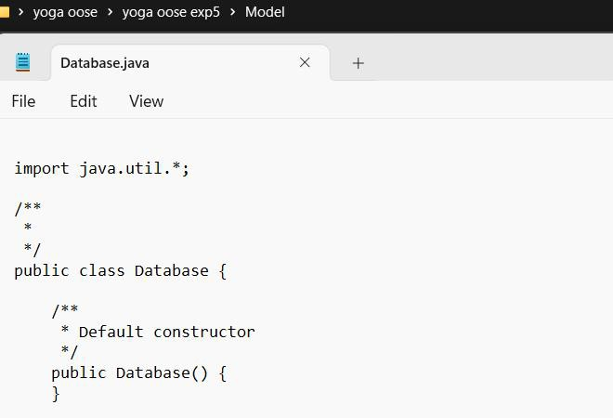

EMPLOYEE
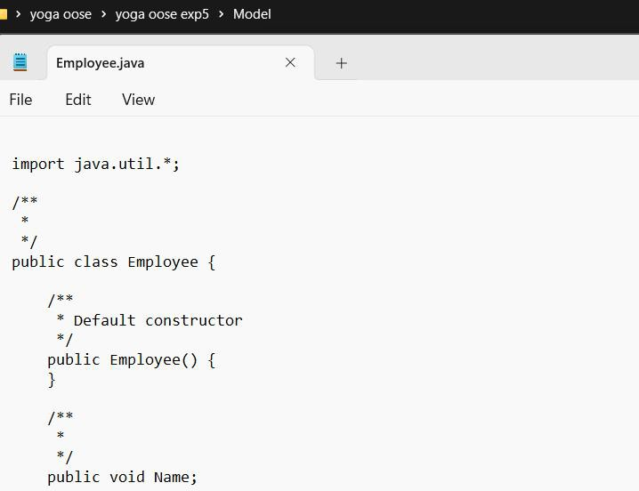

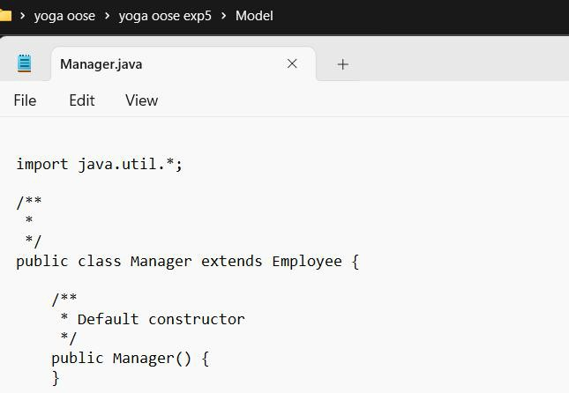

PRODUCT
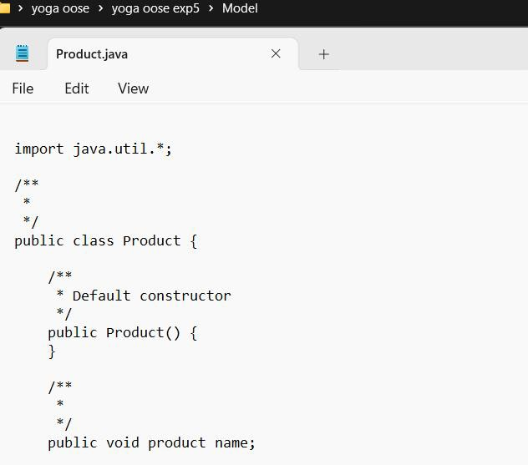
SALES PERSON
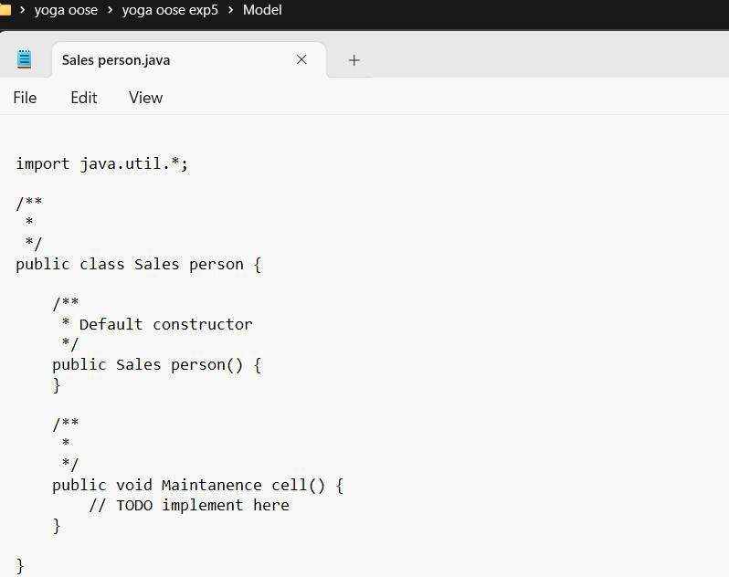

Result:
Thus, the UML diagrams for Inventory system in StarUML has been designed and java code template was generated successfully.

AUTOMATING THE BANKING SYSTEM

AIM
To develop the Automating the banking System using StarUMl.

PROBLEM ANALYSIS ANDPROJECT PLANNING

INTRODUCTION
Banking is one of the common day to day activities of life. Nowadays it is totally different from what existed a few years back, today banking has become completely
computerized, new facilities such as credit cards, debit cards & ATM has been introduced. ATM stands for Automatic Teller Machine which is basically used to withdraw money froman account.

OBJECTIVES
The objective of this software is similar to the ATM software installed in an ATM
center. It first validates the pin of the ATM card, then the type of transaction is enquired and the information from the customer is validated. If it is a withdrawal the amount is asked.
After the money is delivered the transaction details are updated in the database where thecustomer’s information is stored.

SCOPE
The scope of the project is to design an ATM system that will help in completely
automatic banking, this software is going to be designed for withdrawal and deposit and alsoregister the transaction in the database where the customer’s information is stored.

PROBLEM STATEMENT
ATM banking is another type of banking where the most frequent type of transaction
made is withdrawal. A user may withdraw as much as he wants until his account holds a sumgreater than his withdrawal amount. ATM is completely automated and there is no necessity of the ATM center being placed at the bank itself. It can be placed in the shopping malls, airports, railway stations etc.
This ATM system can use any kind of interface. But it should be user friendly and not confusing. Help manuals should be provided in case any customer has problem working withthe software.

USE CASE DIAGRAM
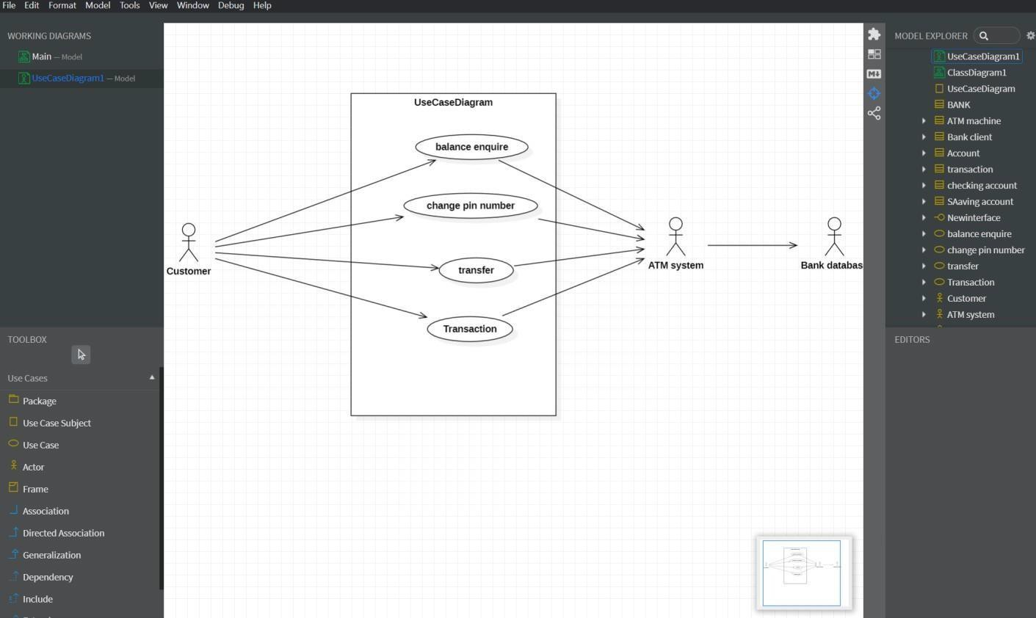
ACTIVITY DIAGRAM
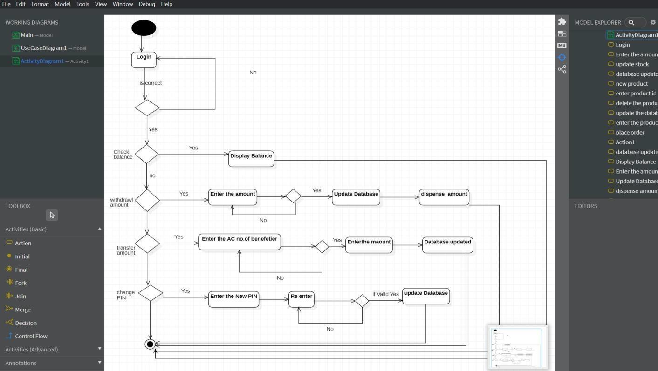

LOGIN
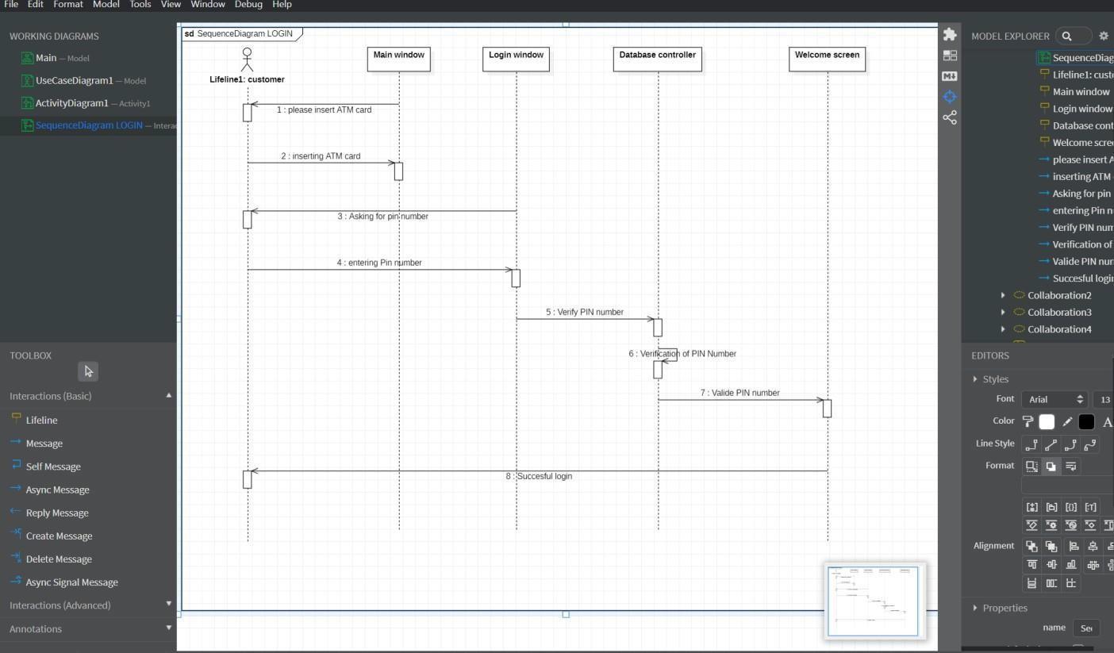
SUCCESSFUL WITHDRAWAL
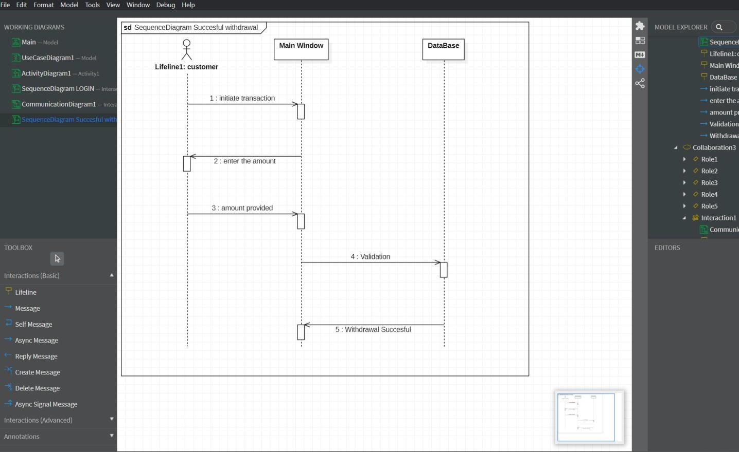

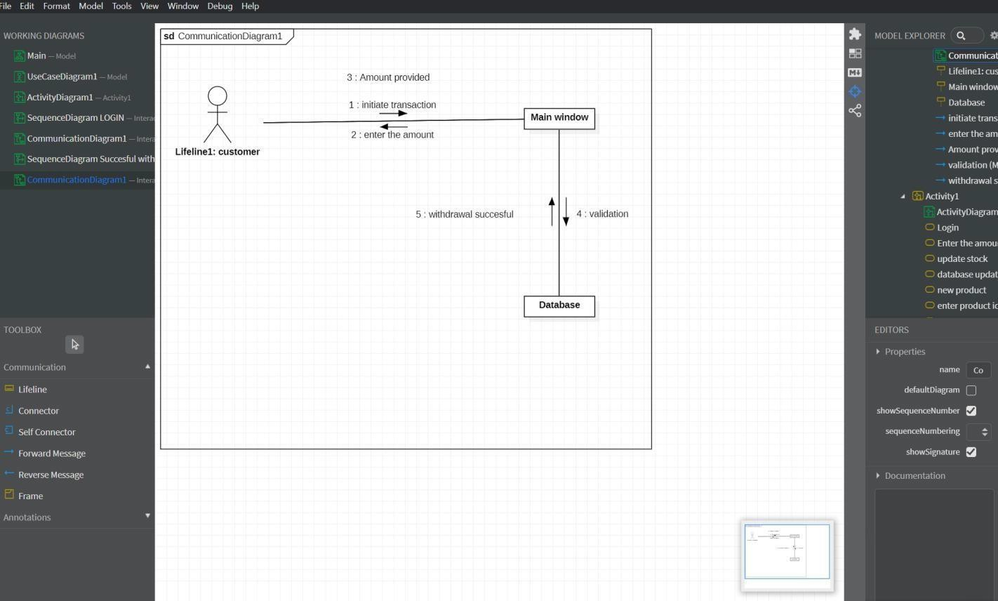

CLASS DIAGRAM
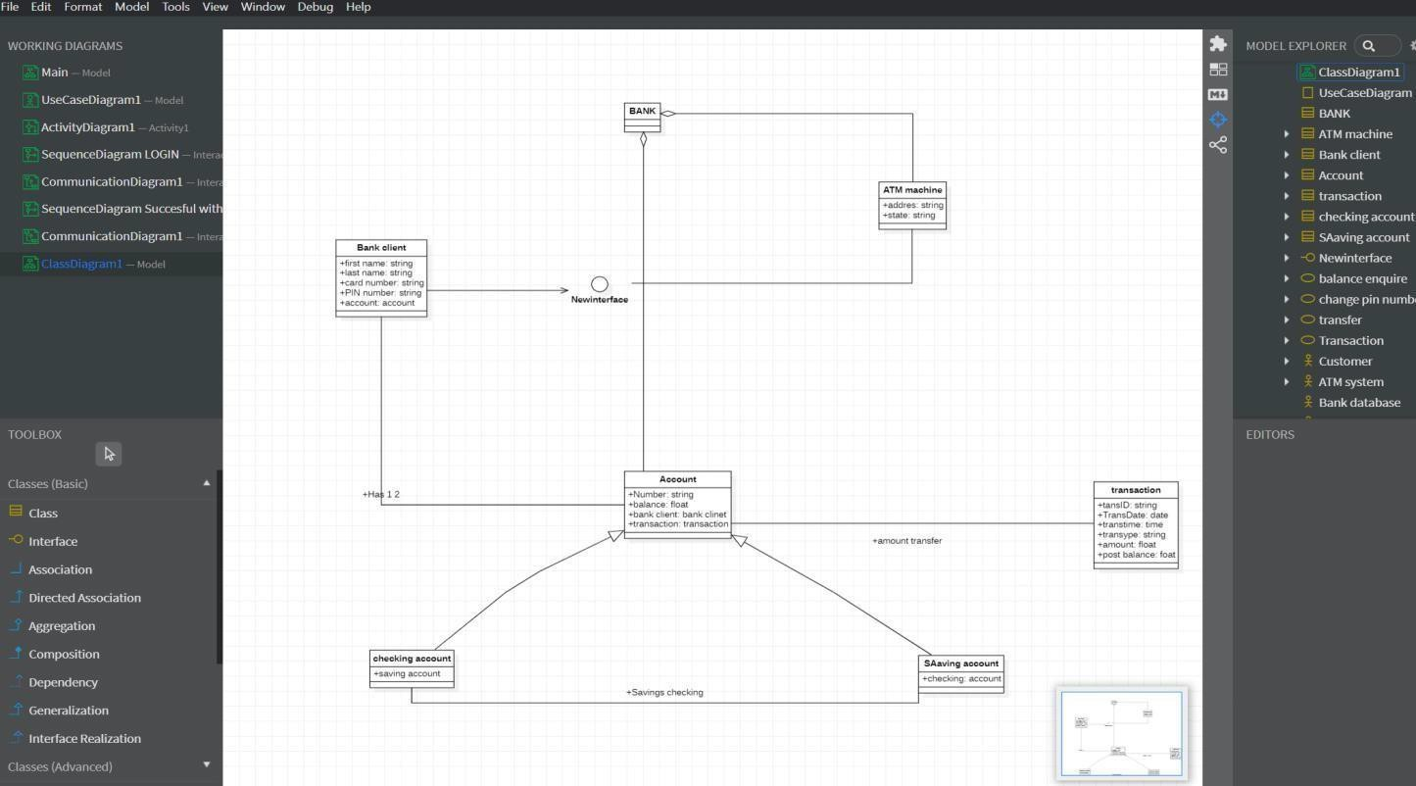

- Draw the class diagram and then save it.
- Open the saved file with star uml.
- Then go to tools at right corner.
- Select the code language which we can prefer.
- Then we have the code generator in tools so give access to it.
- Then go to tools and select the language then it will take us to another window.
- There select the class attribute to generate the code.
- Then it will ask for the directory to store the code.
- Select the directory and click on generate code.
- Then code generated successfully.

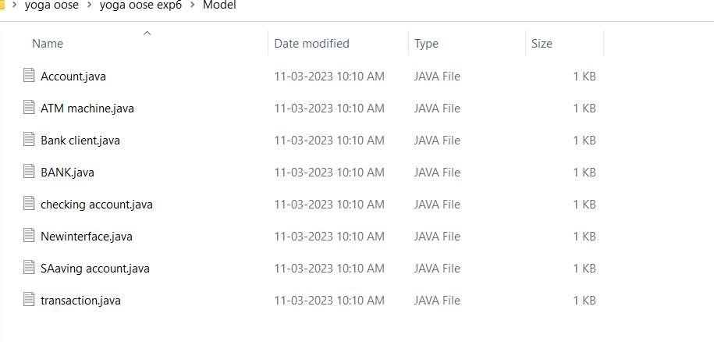
ACCOUNT
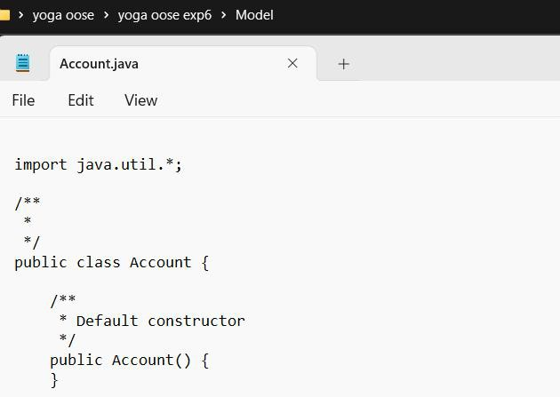

ATM MACHINE

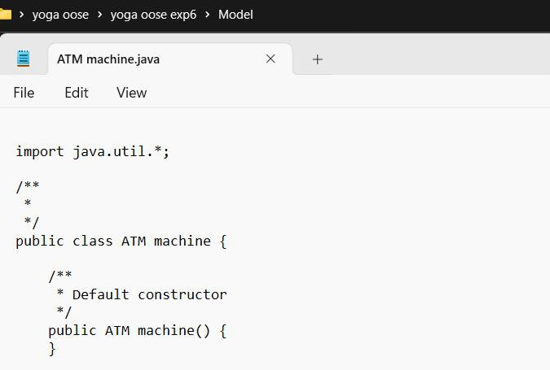

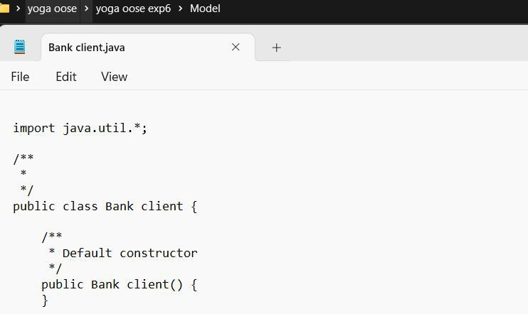

BANK
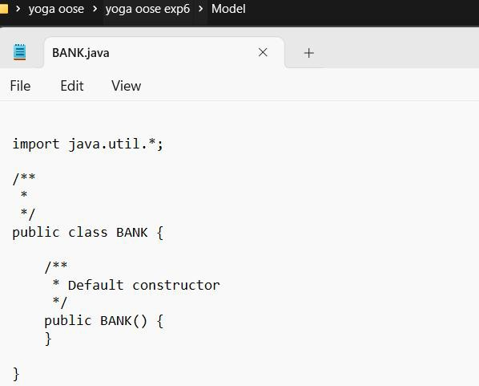

CHECKING ACCOUNT
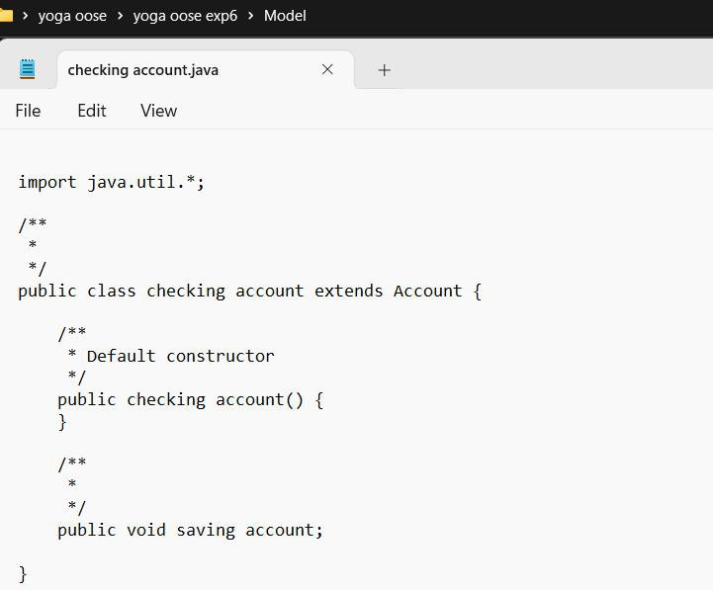

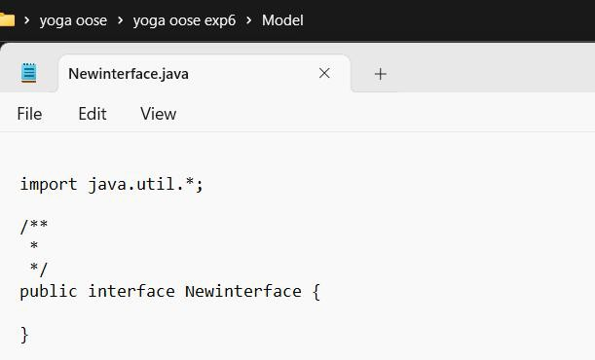

SAVING ACCOUNT
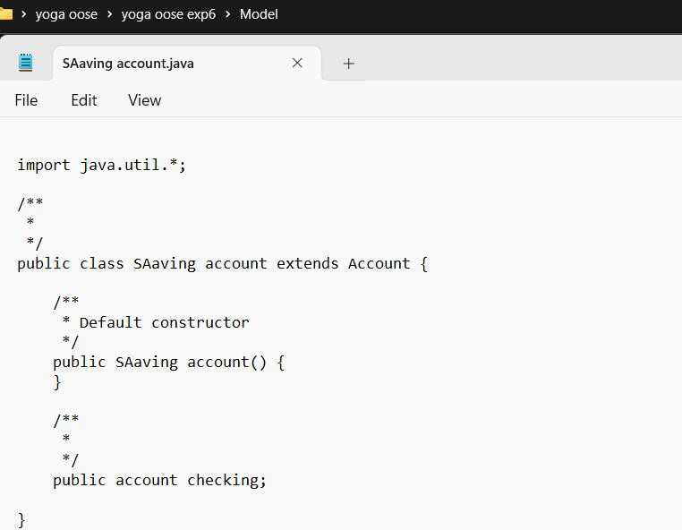

TRANSACTION
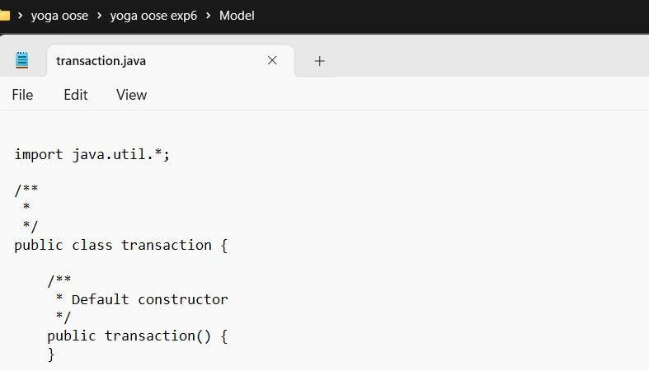

Result:
Thus,the UML diagrams for Banking system in StarUML has been designed and java code
template was generated successfully.

AIM

COURSE REGISTRATION SYSTEM

To develop the Course Registration System using Star UML.

PROBLEM ANALYSIS AND PROJECT PLANNING INTRODUCTION
This software is designed in such a way that it receives the name and other particulars from the student. Based on marks the student has scored the list of possible branches that will accommodate forthe student will be displayed. Only work for the student is what he has to fill in the form and submit it.

OBJECTIVES
The ultimate objective of this software is to eliminate hassles that the student overcomes whileregistering himself. This software will reduce the paper work. This also
reduces the time delay.
SCOPE
The student is first requested to fill the form. This form will contain important
particulars of the student like his name, DOB, preferred branch, his marks. Once the student fills it, a unique id number will be generated. An important thing within this is to decide whatmode the student opts to make the payment. It may either be by demand draft or credit card. As soon as a student is registered then the number of seats available is displayed.

PROBLEM STATEMENT
As project developers we developed a new course registration system to replace the existing manual registration since manual system are prone to errors and take more time.The system made is user friendly and reduces the burden of users. Our system can be made available even in the website of a college.
Students can easily register the course in our system without any difficulty and can
easily understand and also the time taken for registration is less when compared to manual registration. Options are given to the student to select their electives and also it shows the number of papers available along with the number of students who have registered and alsothe number of days for particular elective per semester is also displayed at the side. This makes their work easier as compared to manual registration since they need to make a copyof HOD, staff separately and even if one is missed out the whole process has to be redone. Their information will be stored as soon as they are registered.

USE CASE DIAGRAM
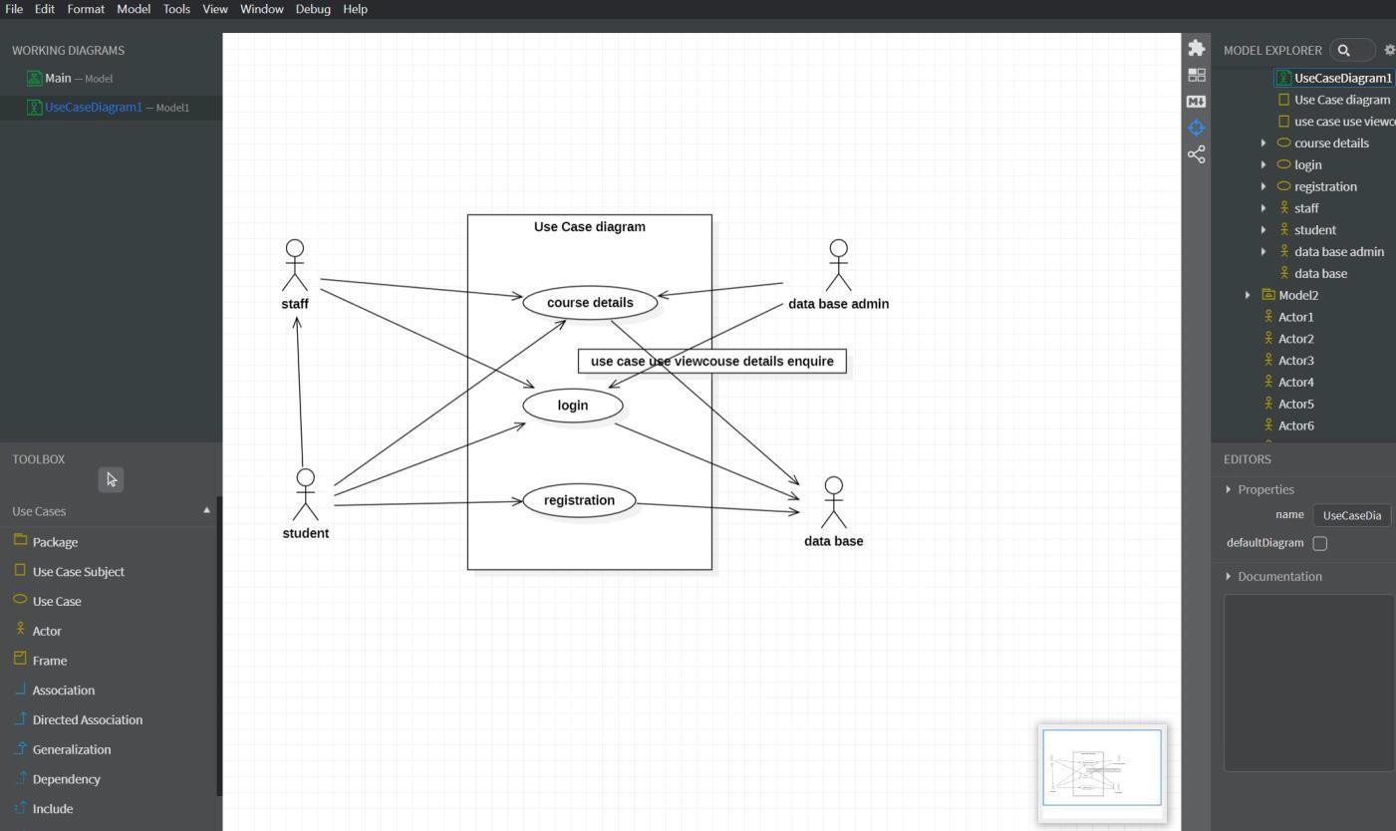

ACTIVITY DIAGRAM
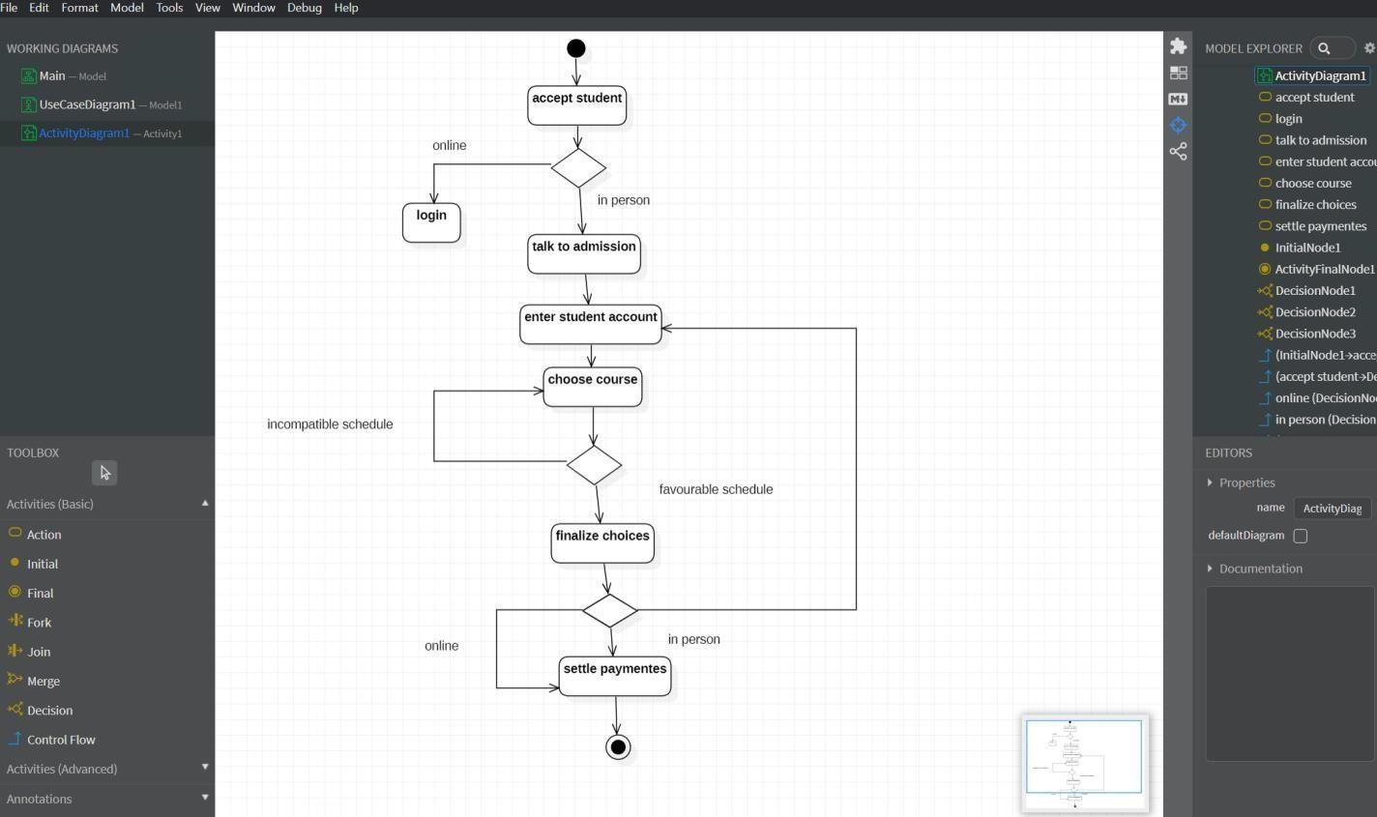

DIAGRAM VALID LOGIN
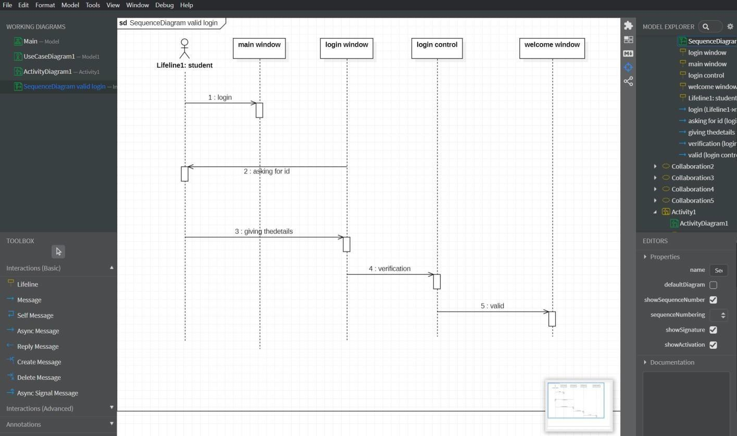

REGISTRATION
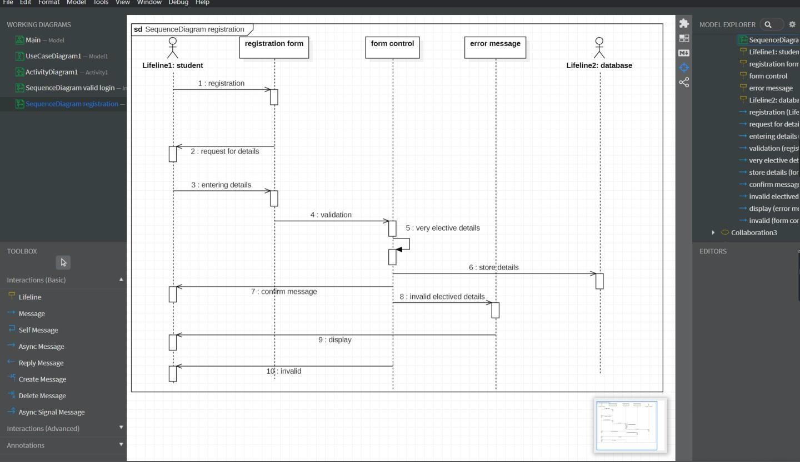

LOGIN
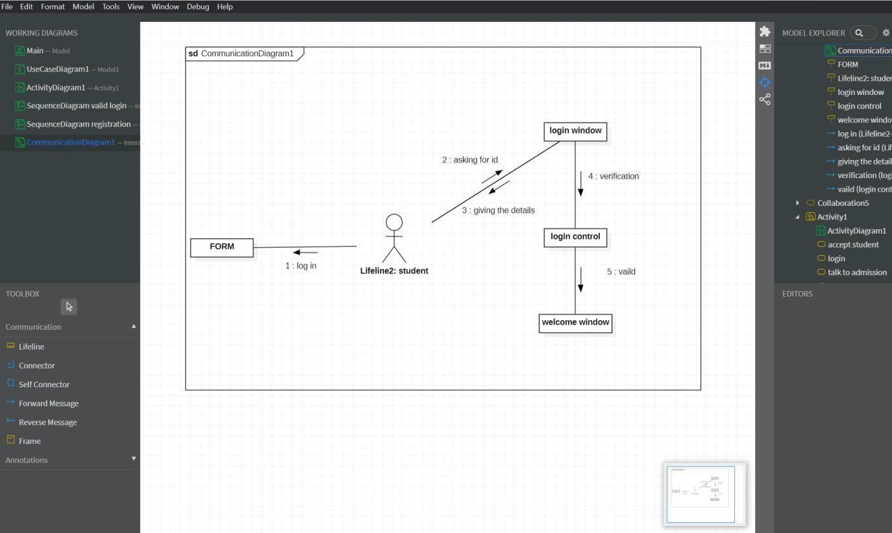

REGISTRATION
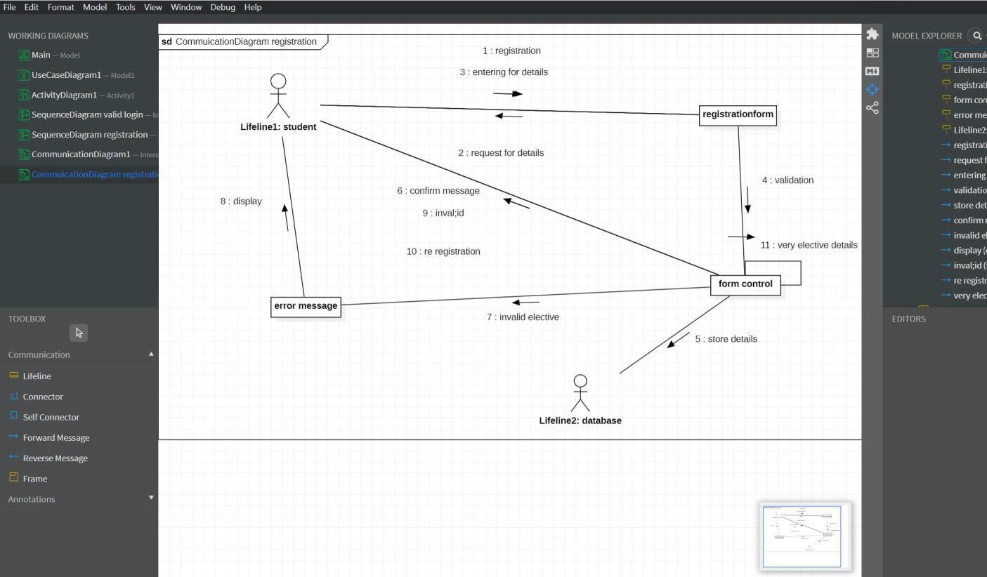

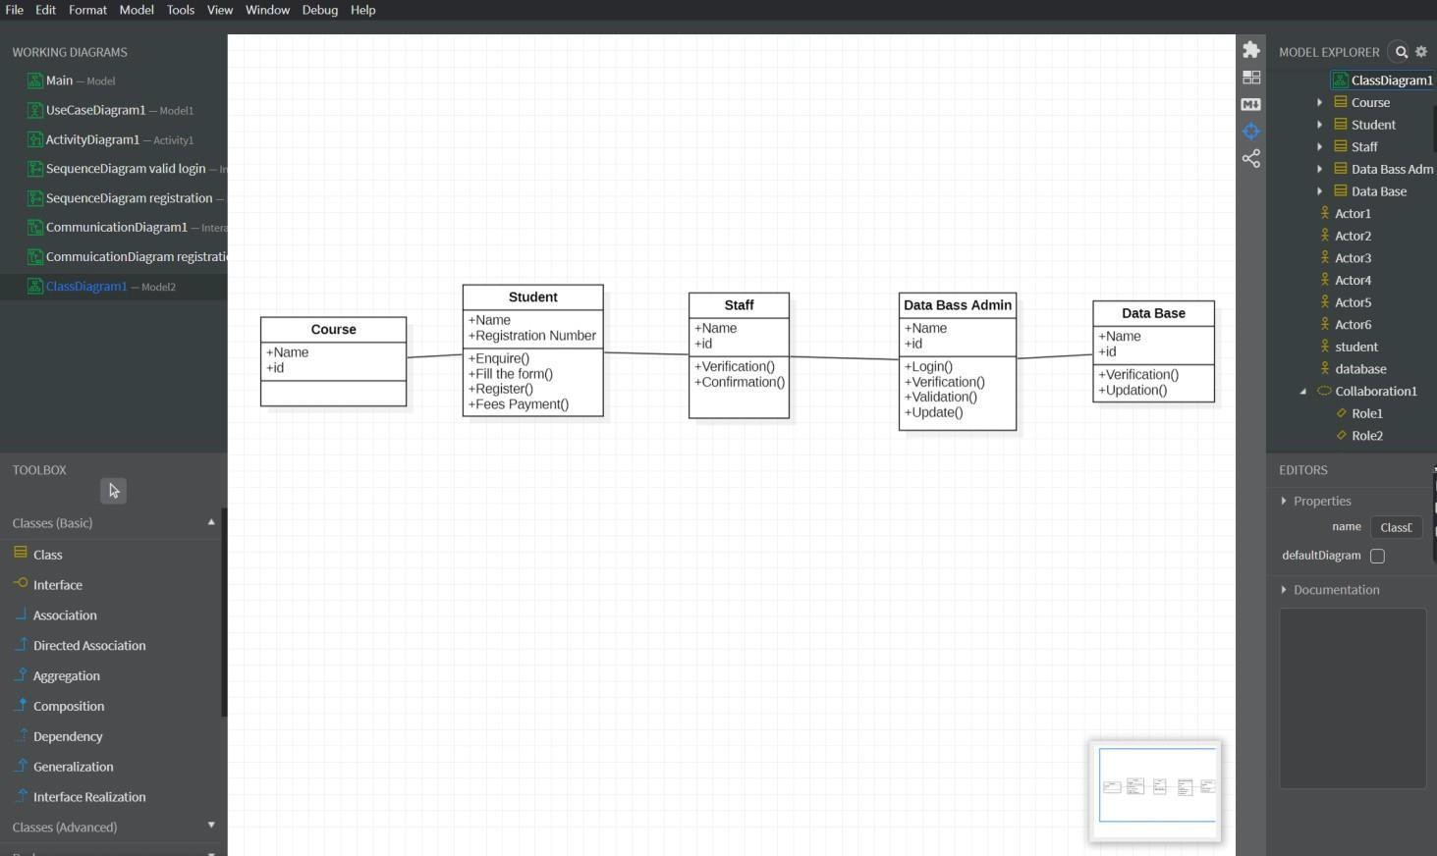

STEPS TO GENERATE CODE IN STAR UML

- Draw the class diagram and then save it.
- Open the saved file with star uml.
- Then go to tools at right corner.
- Select the code language which we can prefer.
- Then we have the code generator in tools so give access to it.
- Then go to tools and select the language then it will take us to another window.
- There select the class attribute to generate the code.
- Then it will ask for the directory to store the code.
- Select the directory and click on generate code.
- Then code generated successfully.

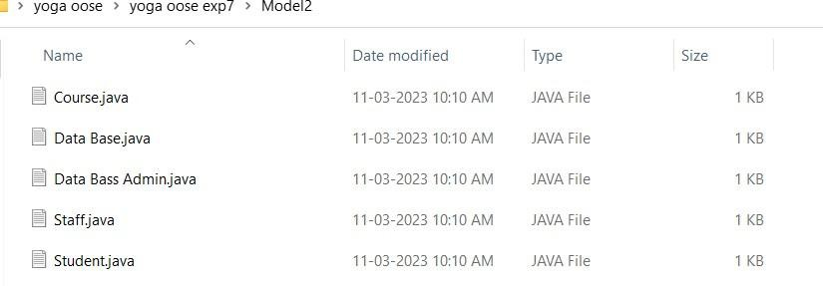

COURSE
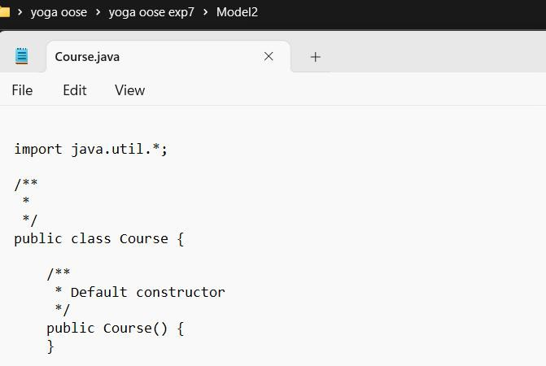

DATA BASE
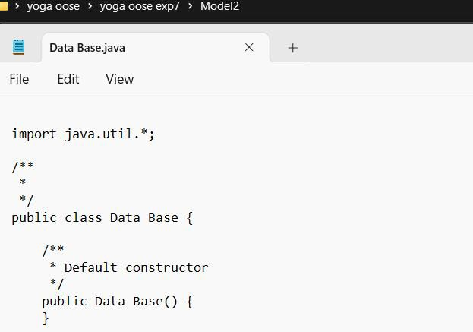

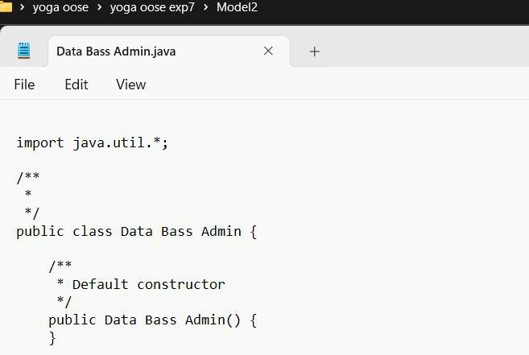

STAFF
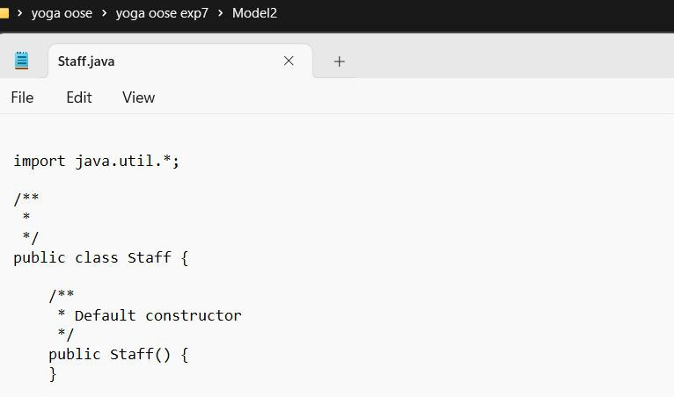

STUDENT
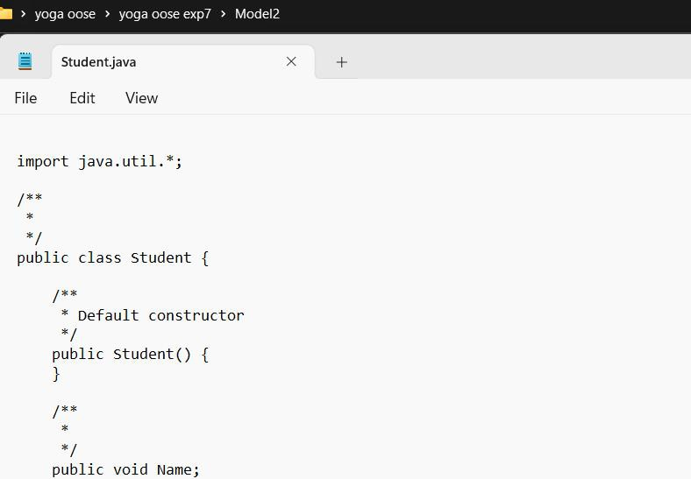

Result:
Thus,the UML diagrams for Course registration system in StarUML has been designed and java code template was generated successfully.

LIBRARY MANAGEMENT SYSTEM

AIM
To develop the Library Management System using Star UML.

INTRODUCTION
To design a library management system using IBM Rational Rose. Implement this system usingVisual Basic Language with Oracle/SQL.

OBJECTIVE
Recently the importance of library management system within the service context of libraries has been unchallenged .Students check the list of books available and borrow the books if the book is a borrow book otherwise it is of waste for the student to come to the library to come to check for the books if the student doesn’t get the book. Then the librarian checks the student id and allows the member to check out the book and the librarian then updates the member database and also the booksdatabase.

SCOPE
This system would be used by members who may be students or professors of that University to check the availability of the books and borrow the books, and by the librarian to update the databases.The purpose of this document is to analyze and elaborate on the high level needs and features of the Online Library System. It focuses on the capabilities and facilities provided by a Library.

PROBLEM STATEMENT
The Library Management System is designed & developed for a receipt and issuance of books in the library along with the student’s details. A librarian can add, delete and update book status and search from the database. A user can borrow, return books, reserve books and search for books. He can also renew his loan period. If a book is overdue, the user will be fined Rs.5 each day over the due. If a book is reported lost, the user will pay the full cost of the book. The books received in the library areentered in Books Entry form and the new student is entered in the student entry form. When the student wants to get the desired book the same is issued on the availability basis to the student.

USE CASE DIAGRAM
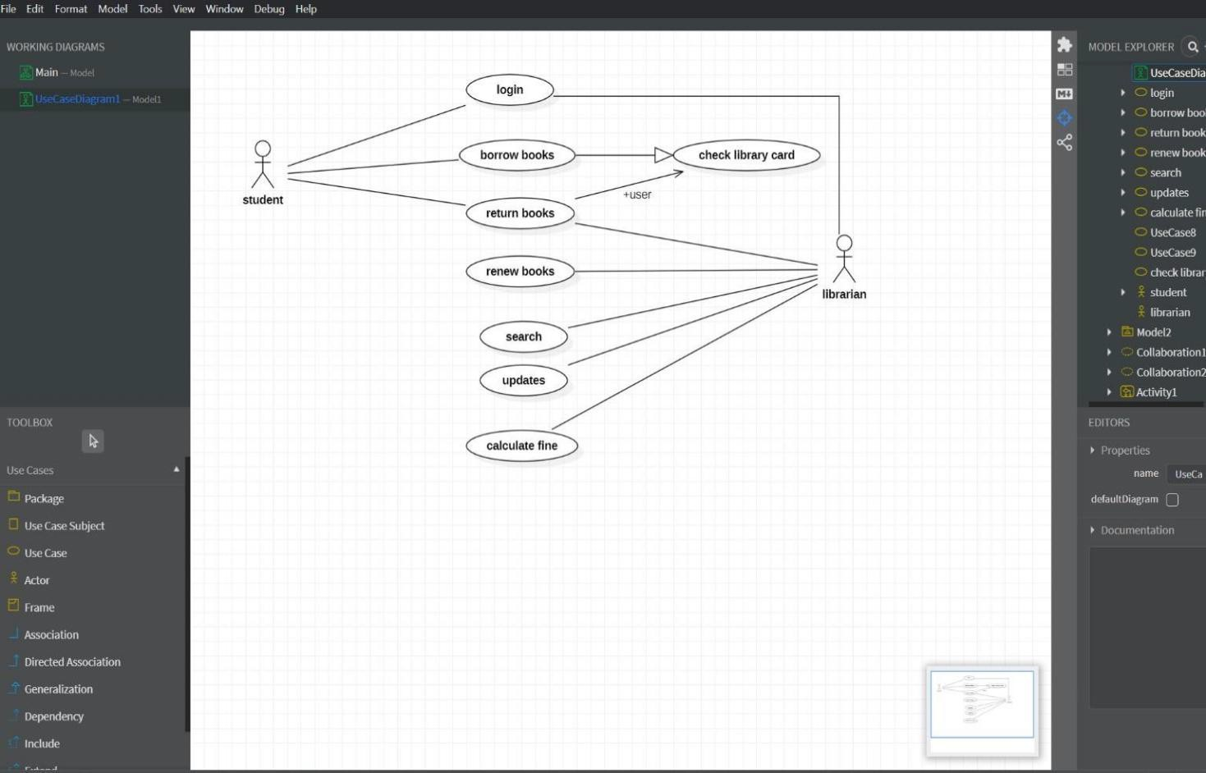

ACTIVITY DIAGRAM
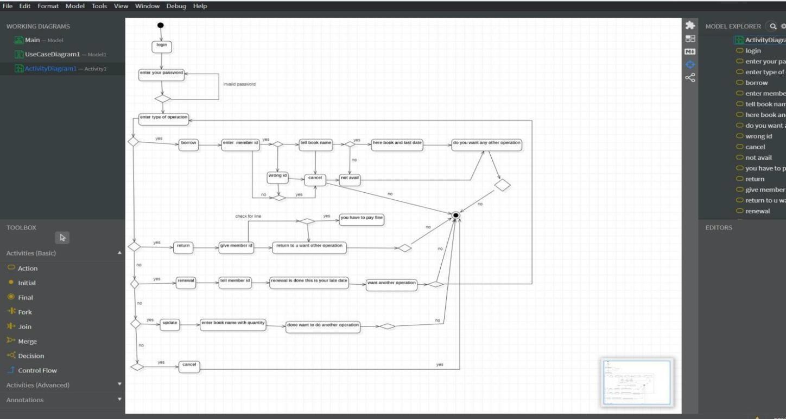

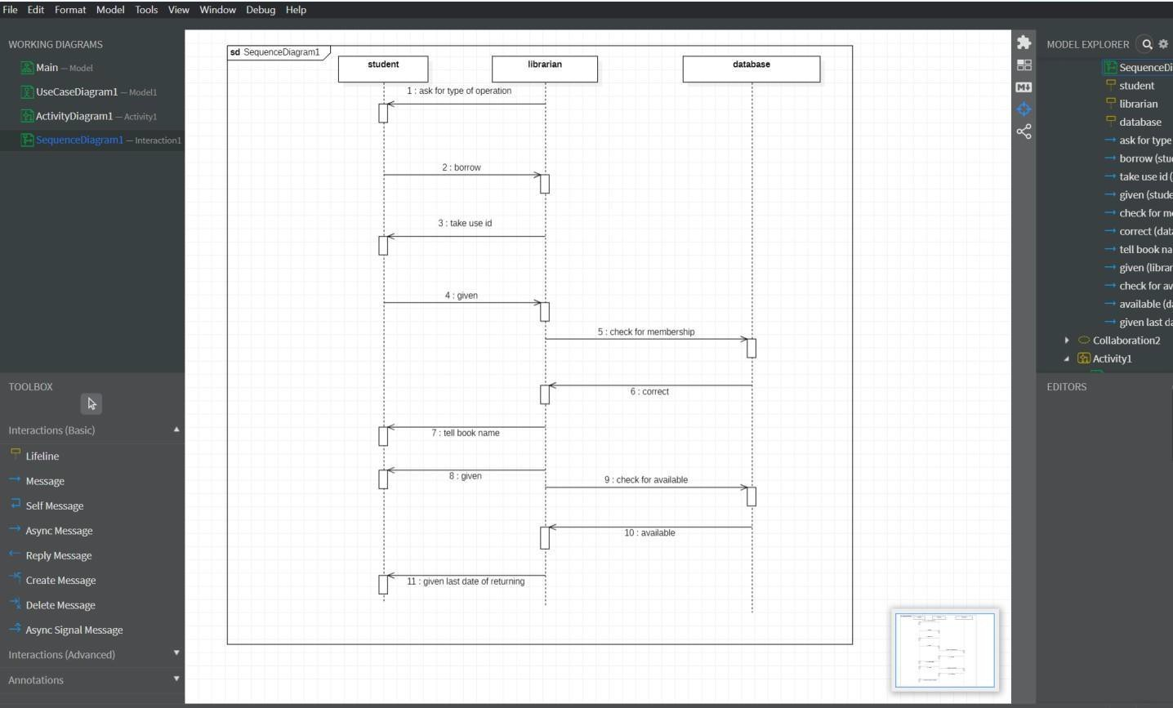

COMMUNICATION DIAGRAM
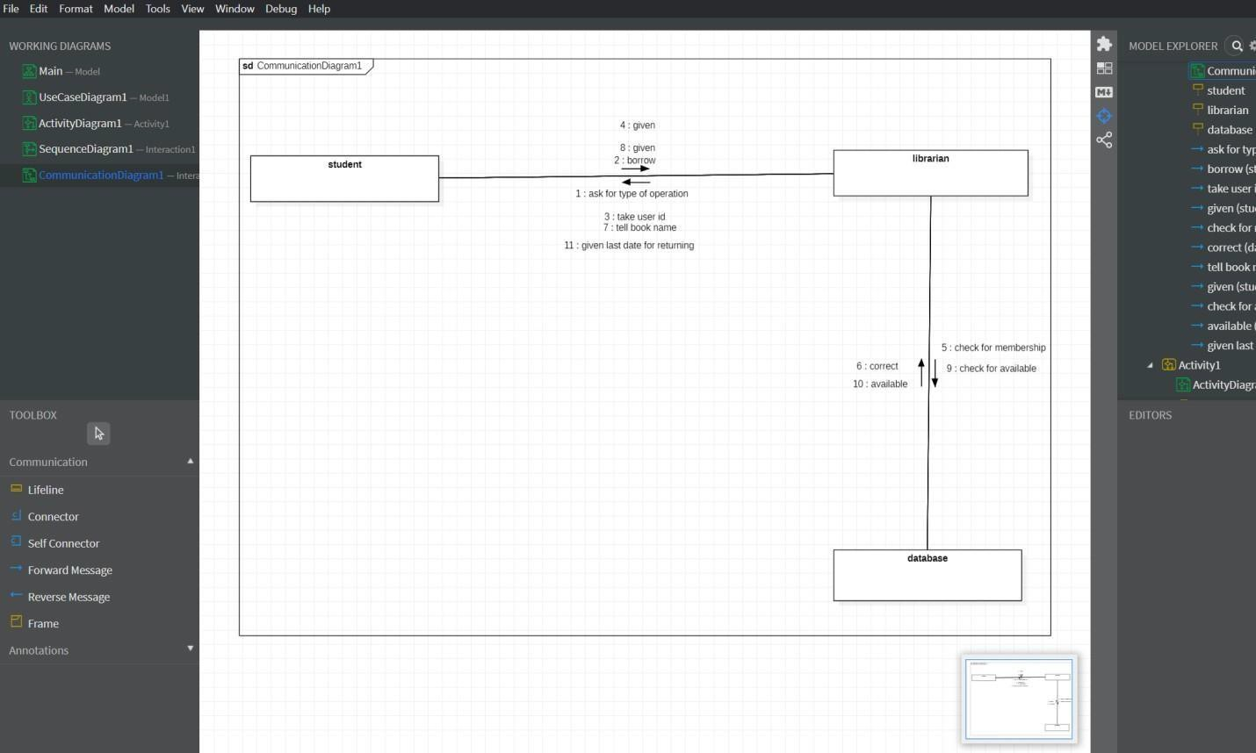

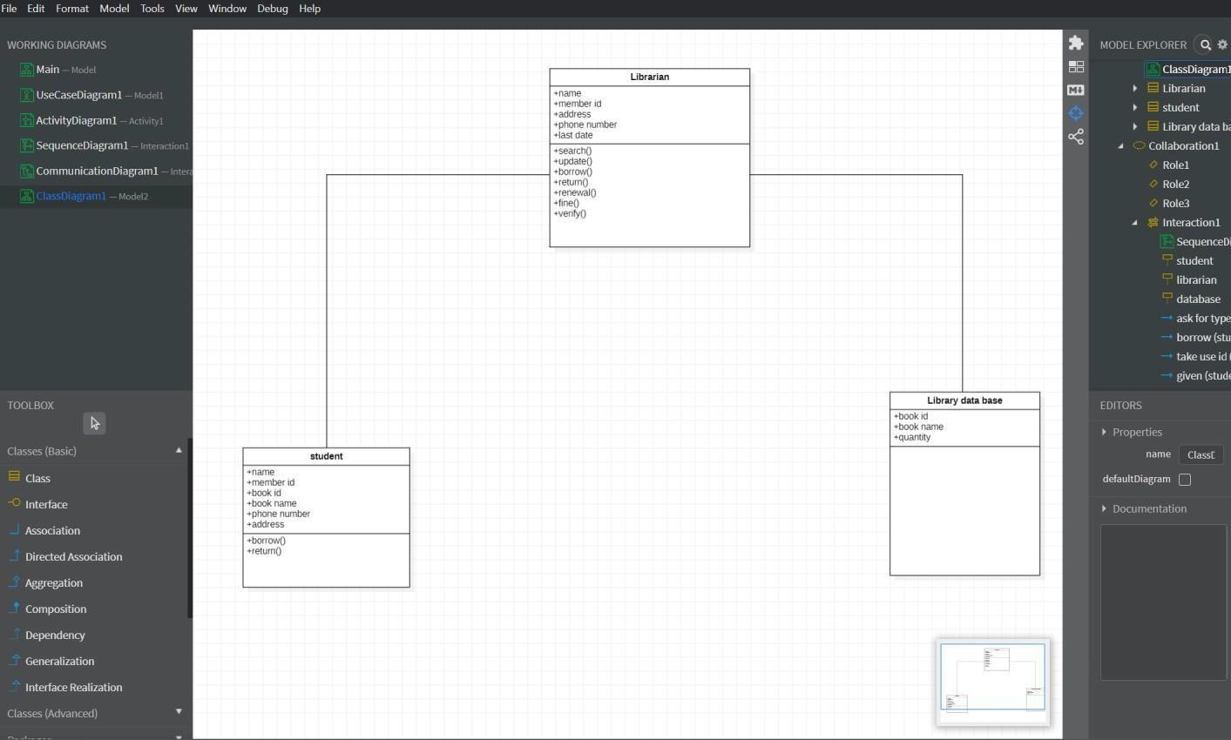

STEPS TO GENERATE CODE IN STAR UML

- Draw the class diagram and then save it.
- Open the saved file with star uml.
- Then go to tools at right corner.
- Select the code language which we can prefer.
- Then we have the code generator in tools so give access to it.
- Then go to tools and select the language then it will take us to another window.
- There select the class attribute to generate the code.
- Then it will ask for the directory to store the code.
- Select the directory and click on generate code.
- Then code generated successfully.

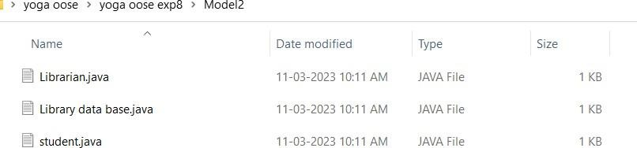

LIBRARIAN
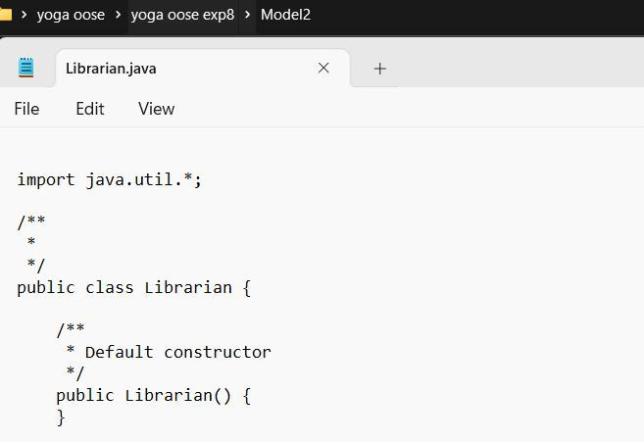

LIBRARY DATA BASE
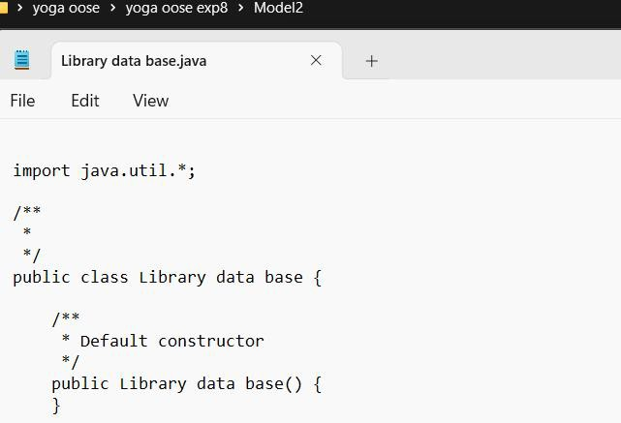

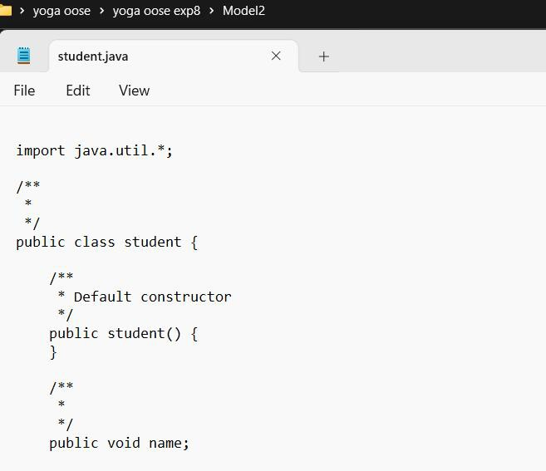

RESULT:
Thus,the UML diagrams for Library Management system in StarUML has been designedand java code template was generated successfully.

PASSPORT AUTOMATION SYSTEM

AIM
To develop the Passport Automation System using StarUML

OBJECTIVE

To develop the passport automation system software using UML language. It is the interface between applicant and authority responsible for issue the passport. It aims atimproving efficiency and reducing complexities.

SCOPE

The system provides the online interface to the user where we can fill their form and personal detail with necessary proof. The authority concerned with the issue of passport can use this system to reduce is workload and process it speedy manner. It provides communication platform between administrator and applicant. To transfer the data between passport authorityand local police verifying the applicant’s information.

PROBLEM STATEMENT

My project title is passport automation system. In this project we can develop the modules such as login, fill the form with necessary proof, verifying the applicant’s information, validity checking and issue the passport for that particular applicant. In this login module, wecan perform that that perform that enters into the login website for the different actors, and then fill for the can be done by the primary and verification, checking and issuing the passport can be done for the supporting actor.

USE CASE DIAGRAM
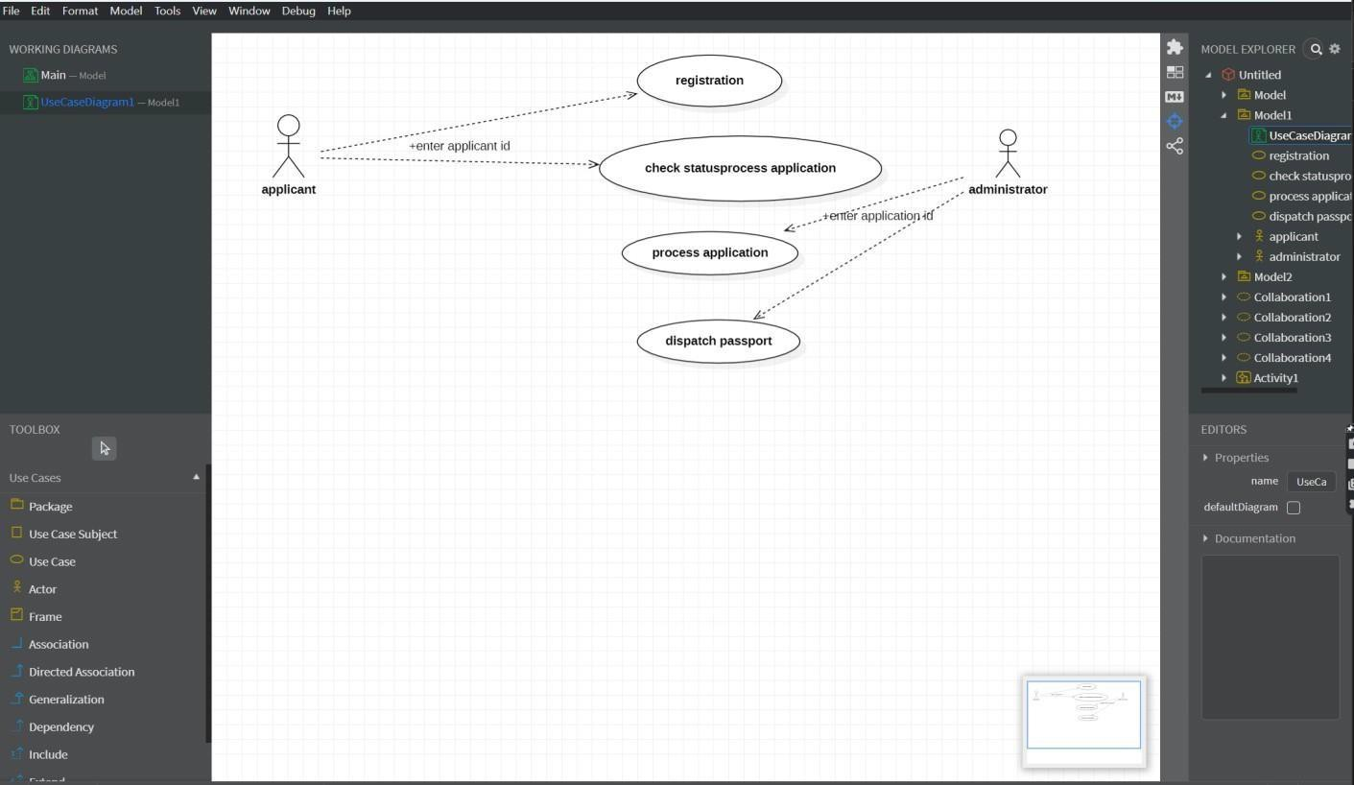

ACTIVITY DIAGRAM
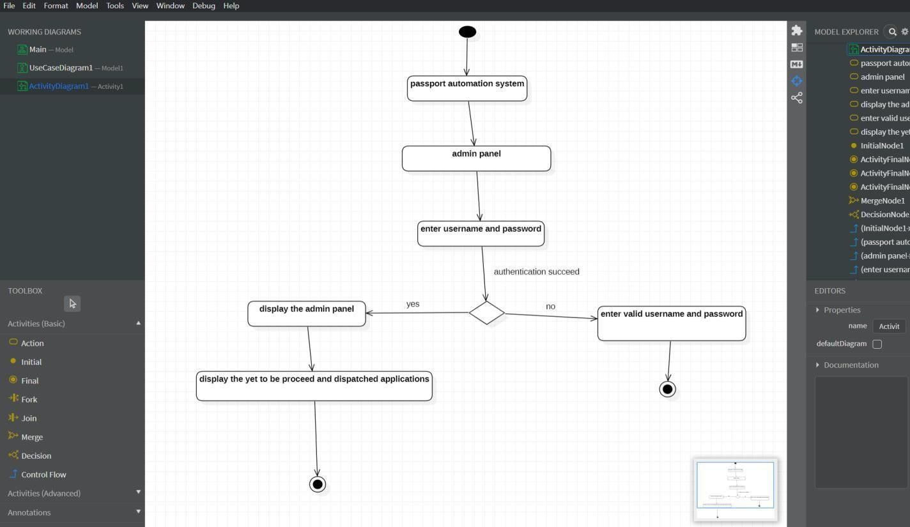

DIAGRAM

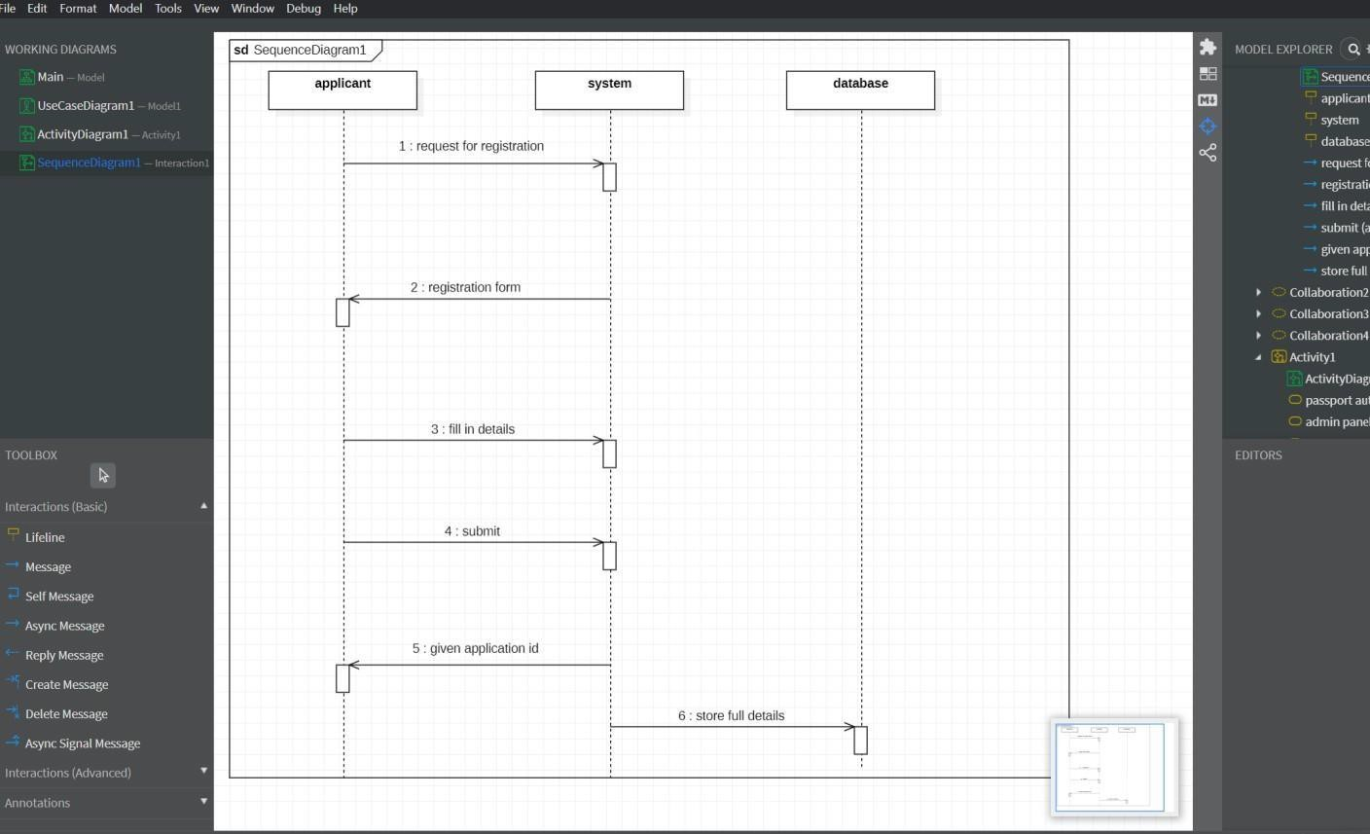
NEW REGISTRATION

ADMIN PANEL

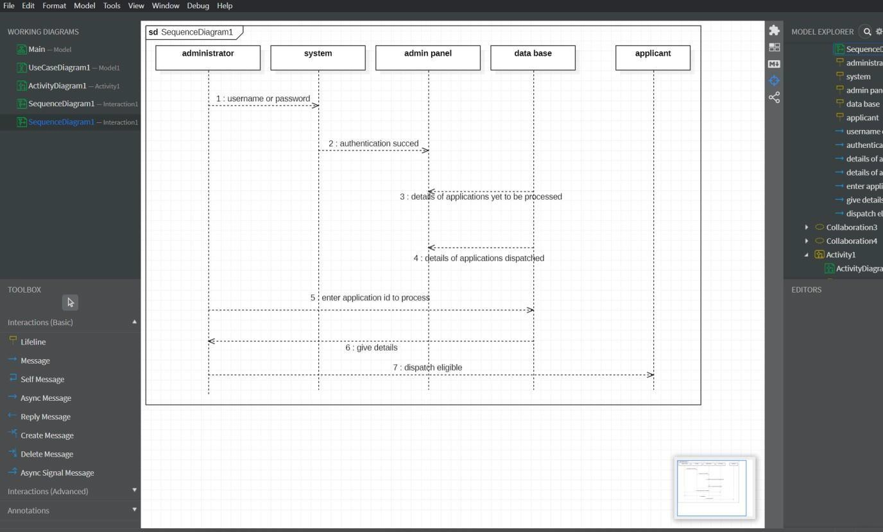

NEW REGISTRATION
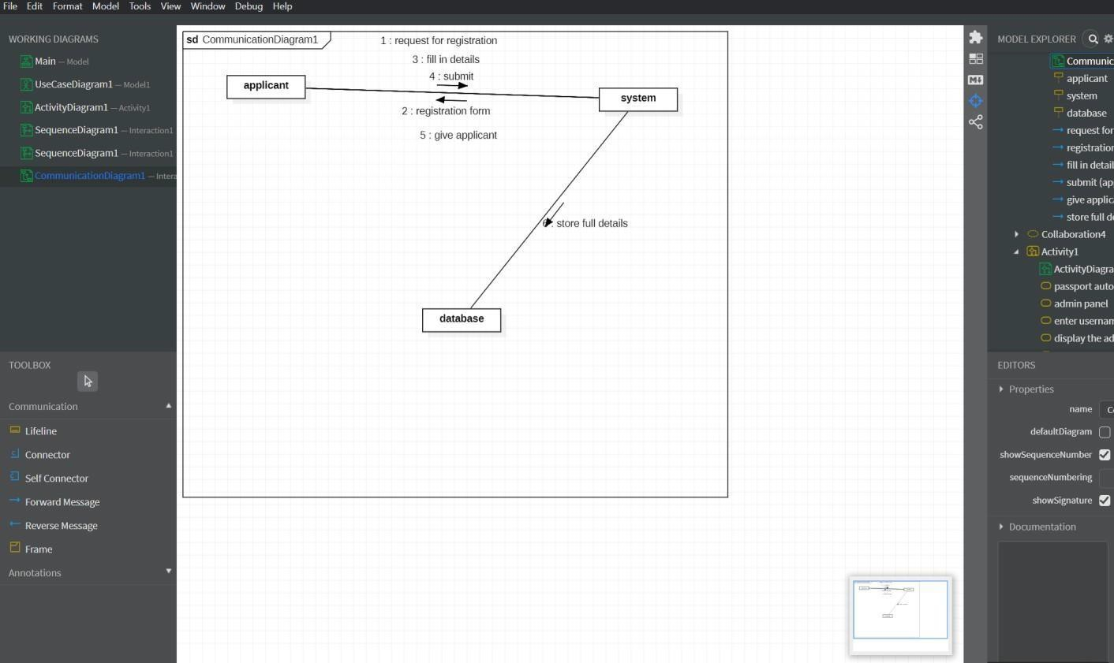

ADMIN PANEL
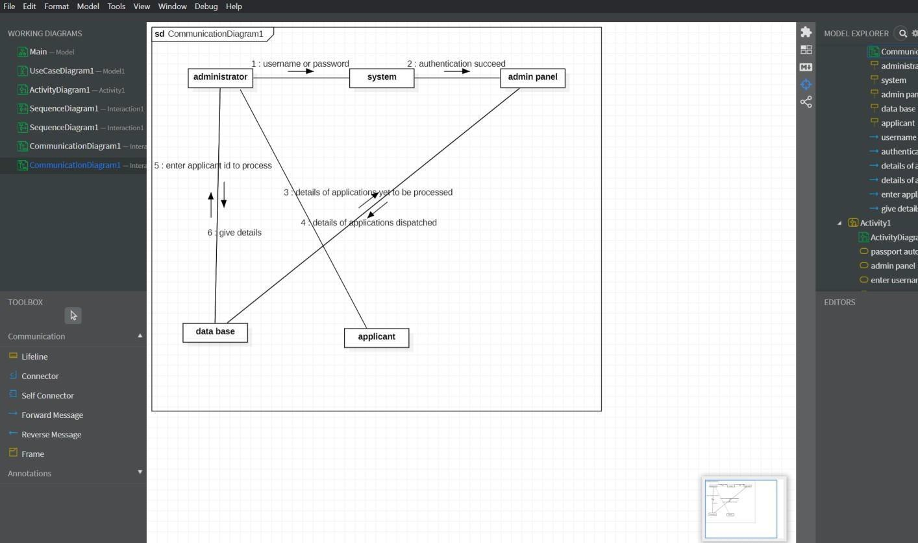

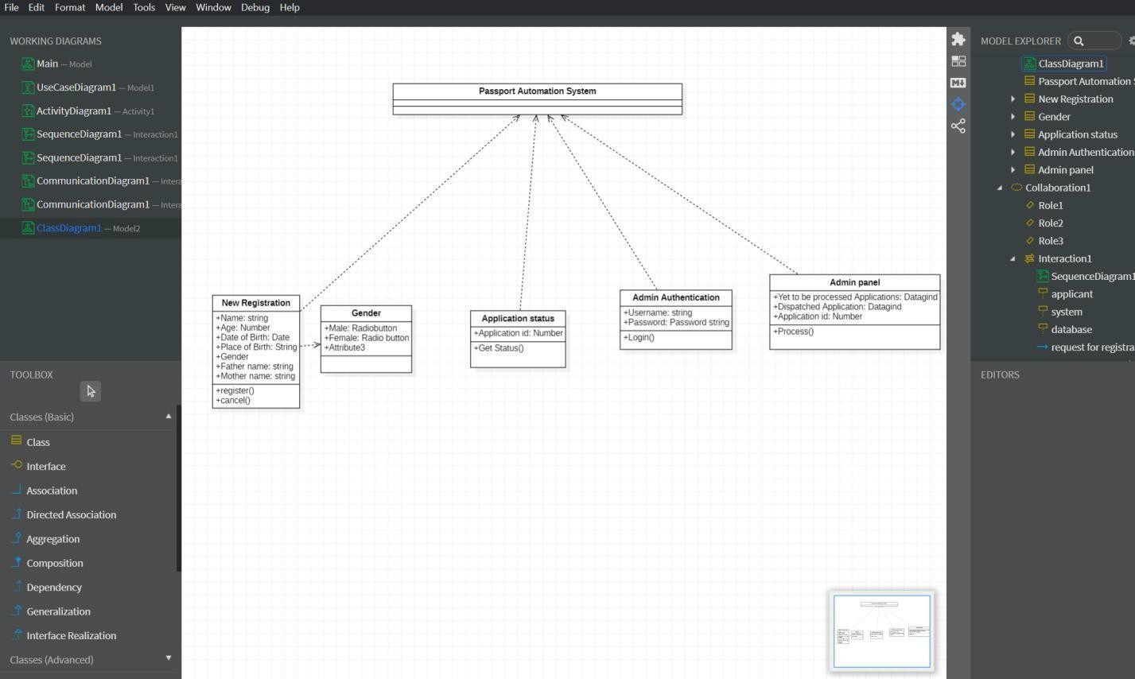

STEPS TO GENERATE CODE IN STAR UML

- Draw the class diagram and then save it.
- Open the saved file with star uml.
- Then go to tools at right corner.
- Select the code language which we can prefer.
- Then we have the code generator in tools so give access to it.
- Then go to tools and select the language then it will take us to another window.
- There select the class attribute to generate the code.
- Then it will ask for the directory to store the code.
- Select the directory and click on generate code.
- Then code generated successfully.

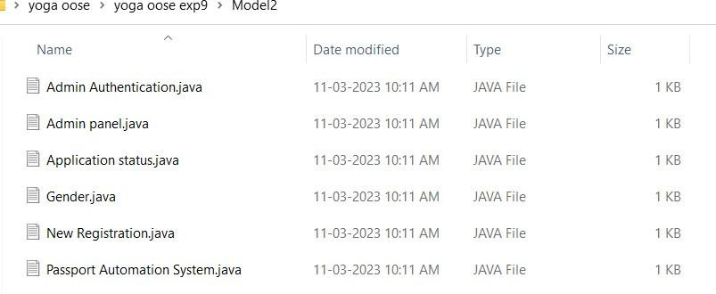

ADMIN AUTHENTICATION
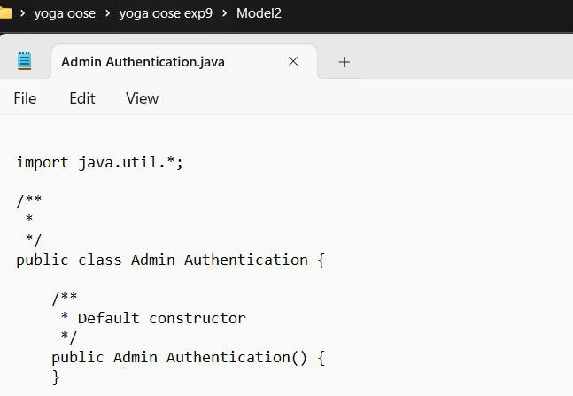

ADMIN PANEL
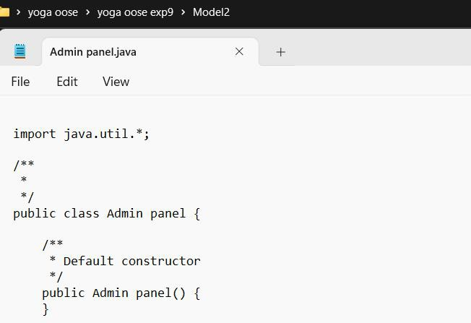

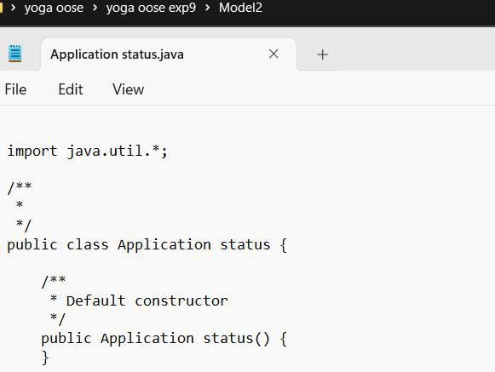

GENDER
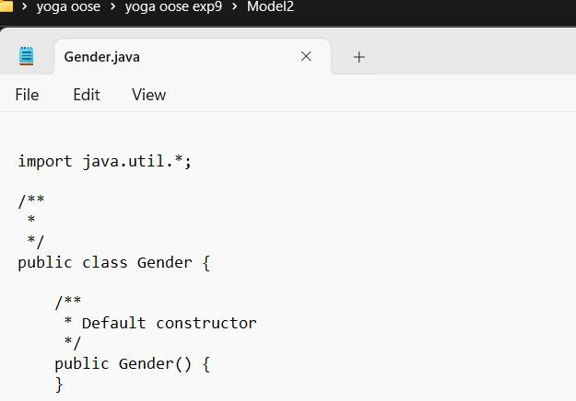

NEW REGISTRATION
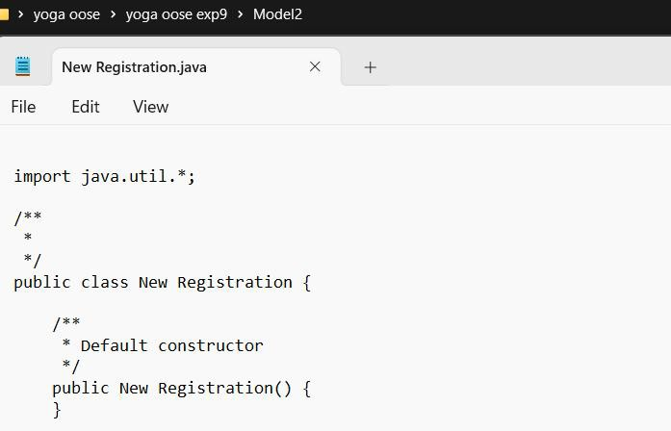

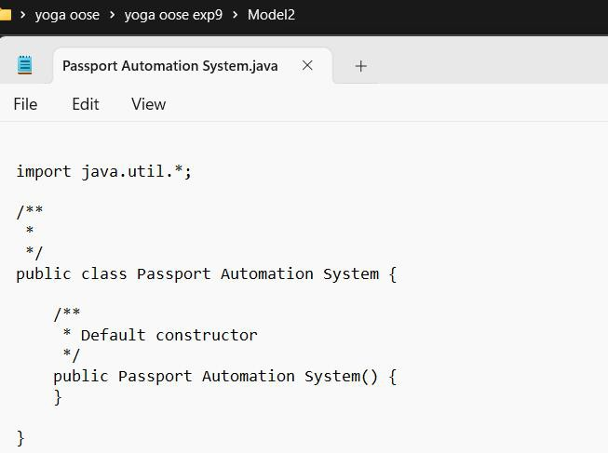

Result:
Thus,the UML diagrams for Passport Automation system in StarUML has been designed and java code template was generated successfully.

